

PARAMOUNT+ WILL EXCLUSIVELY PREMIERE “GHISLAINE – PARTNER IN CRIME,” A FOUR-HOUR DOCUMENTARY ON THE INFAMOUS ACCOMPLICE TO JEFFREY EPSTEIN

Features the Only Extensive On-Camera Interview with Juror #50

Series to Stream Thursday, April 7

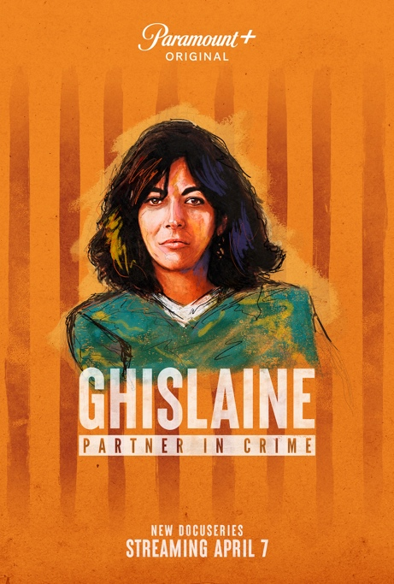

Click HERE For Preview

April 5, 2022 – Paramount+ will exclusively premiere GHISLAINE – PARTNER IN CRIME, an all-new four-hour documentary series exploring the life of Ghislaine Maxwell, the infamous partner to Jeffrey Epstein. The full series will be available to stream starting Thursday, April 7 on Paramount+.

GHISLAINE – PARTNER IN CRIME features revealing, emotional interviews with Maxwell’s siblings Ian, Kevin and Isabel Maxwell; her friends; legal experts; and her alleged victims. The docuseries unravels the shocking pyramid scheme of sexual abuse that Maxwell controlled, and uncovers what really happened at Epstein’s properties, including his private island. GHISLAINE – PARTNER IN CRIME also features the first extensive television interview with Scotty David, known as Juror #50, who takes viewers inside the jury room. Juror #50 would throw a curveball post-verdict that no one saw coming. His revelations of what he had not put on his juror questionnaire pushed Maxwell’s defense to file for a new trial.

“Some jurors did have serious credibility issues with some of these victims because of memories,” David says. “How can you forget what happens? So, I felt like it was very important that I shared my sexual abuse story. When I shared that with them, I told them I could literally play back my experience in my head like a video. Sure, there are certain things that do run together and are blurred … I feel like that helped other people come to the conclusion that just because some memories are fuzzy doesn’t mean that they’re not telling the truth.”

“GHISLAINE – PARTNER IN CRIME paints a vivid picture of Maxwell’s privileged yet turbulent lifestyle, from the parties and the A-list friendships to the trial,” says Susan Zirinsky, president of See It Now Studios. “This docuseries explores her own family’s ability to cope with adversity, and asks how this woman, who seemed to have it all, risked it all to help Jeffrey Epstein.”

“It’s very exciting to be partnering with Susan Zirinsky for the first time to delve deeper into the Ghislaine Maxwell story,” says Fatima Salaria, managing director of Fremantle. “The series is packed with fresh expert analysis of both Maxwell’s life and the dramatic trial, which is vividly brought to life with the unique perspective of Juror #50, Scotty David.”

“Ghislaine got me to the point where I trusted her so much [that] I then walked myself into a predator’s home,” says Teresa Helm, who says she’s a survivor of Maxwell and Epstein’s operation. Teresa Helm did not testify but attended the trial.

Maxwell’s journey begins as the daughter of Robert Maxwell, a wealthy media magnate scrutinized over questionable business deals, who then died mysteriously while out to sea in his yacht. It ends with Jeffrey Epstein, a money manager and convicted sex offender, who died while being held on federal sex trafficking charges. Epstein had a powerful coterie of friends. Along the way, Ghislaine Maxwell’s story includes ties to the rich and famous. Allegations surfaced that she arranged dates for Britain’s Prince Andrew with young women. In March, Prince Andrew paid an undisclosed sum to Virginia Giuffre to settle a lawsuit in which she claimed Epstein and Maxwell forced her to have sex with the prince at Maxwell’s home in London. The prince denies any wrongdoing.

“The ghost in this whole affair is Jeffrey Epstein,” says Ian Maxwell. “He died in August 2019; Ghislaine was arrested in 2020. There has to be somebody to pay the price. There has to be the patsy … Ghislaine is paying that price.”

The four-part series looks at how deeply Maxwell was involved in recruiting, grooming, and trafficking some girls as young as 14 for sexual abuse. Testimony described a ring that abused hundreds of women and girls, and how the former socialite became an accomplice to one of the worst sex offenders in history.

Maxwell was convicted of sex-trafficking related crimes in December 2021. Maxwell is scheduled to be sentenced in late June and could spend as long as 65 years in prison.

GHISLAINE – PARTNER IN CRIME is produced by See It Now Studios and Fremantle. Francis Baker is the series producer for Fremantle. Fiona Caldwell, Fatima Salaria and Yvonne Alexander are the executive producers. Lisa Honig is the executive in charge for Fremantle. For See It Now Studios, Susan Zirinsky and Terence Wrong are the executive producers, Aysu Saliba is the supervising producer, and Adam Goldfried is the executive director. Daphne Barak is the executive consultant.

About Paramount+:
Paramount+, a direct-to-consumer digital subscription video on-demand and live streaming service, combines live sports, breaking news and a mountain of entertainment. The premium streaming service features an expansive library of original series, hit shows and popular movies across every genre from world-renowned brands and production studios, including BET, CBS, Comedy Central, MTV, Nickelodeon, Paramount Pictures and the Smithsonian Channel. The service is also the streaming home to unmatched sports programming, including every CBS Sports event, from golf to football to basketball and more, plus exclusive streaming rights for major sports properties, including some of the world’s biggest and most popular soccer leagues. Paramount+ also enables subscribers to stream local CBS stations live across the U.S. in addition to the ability to stream the company’s other live channels: CBSN for 24/7 news, CBS Sports HQ for sports news and analysis, and ET Live for entertainment coverage.

For more information about Paramount+, please visit www.paramountplus.com and follow @ParamountPlus on social platform.

About Fremantle
Fremantle is one of the world’s largest and most successful creators, producers and distributors of Entertainment, Drama & Film and Documentaries.

Operating in 26 territories, we are a proudly independent group of content creators. We produce and deliver high-quality multi-genre IP including some of the biggest entertainment formats, most watched international dramas, award-winning films and hard-hitting documentaries, amplifying local stories on a global scale.

From “Too Hot to Handle” to “Mosquito Coast,” “Game of Talents” to “The Hand of God,” “Farmer Wants a Wife” to “Got Talent,” “Family Feud” to “My Brilliant Friend” and „The Investigation” to “Arctic Drift,” our focus is simple – we create and deliver irresistible entertainment.

We are also a world leader in digital and branded entertainment with more than 480 million fans across 1,600 social channels and over 40 billion views per year across all platforms.

Fremantle is part of RTL Group, a global leader across broadcast, content and digital, itself a division of the international media giant Bertelsmann.

For more information, please visit Fremantle.com, follow us @FremantleHQ or visit our LinkedIn and Facebook pages.

Press Contacts:
Susan Lundgren – susan.lundgren@viacomcbs.com
Richard Huff – Huffr@viacomcbs.com

