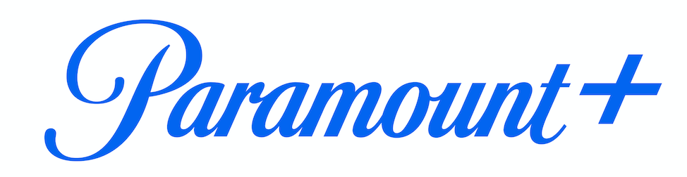

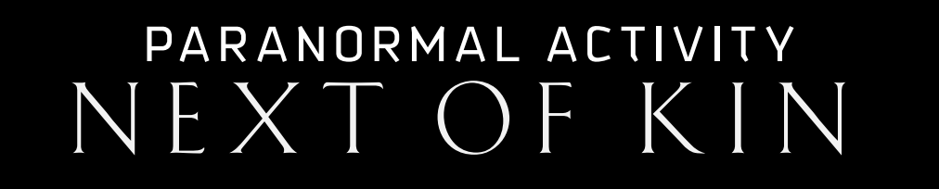

OFFICIAL TRAILER AND KEY ART FOR
“PARANORMAL ACTIVITY: NEXT OF KIN” NOW AVAILABLE

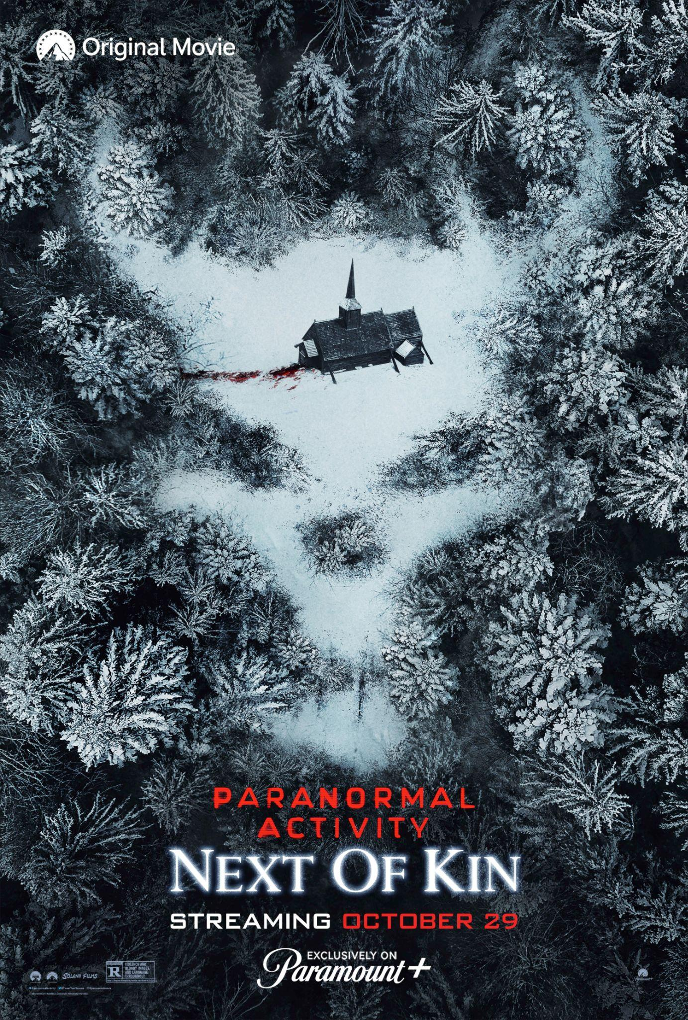

From Paramount Players, the New Installment in the “Paranormal Activity”
Franchise Premieres Friday, Oct. 29, Exclusively on Paramount+

CLICK HERE to Watch the Official Trailer

CLICK HERE to Download the Official Key Art

Oct. 6, 2021 – Paramount+, the streaming service from ViacomCBS, today revealed the official trailer and key art for its upcoming original movie PARANORMAL ACTIVITY: NEXT OF KIN. The new installment in the “Paranormal Activity” franchise arrives just in time for Halloween, and will be available to stream on Friday, Oct. 29, exclusively for Paramount+ subscribers in the U.S.

In PARANORMAL ACTIVITY: NEXT OF KIN, a documentary filmmaker follows Margot (Emily Bader) as she heads to a secluded Amish community, in the hopes of meeting and learning about her long-lost mother and extended family. Following a string of strange occurrences and discoveries, she soon realizes this community that welcomed them into their home might be hiding something sinister…

PARANORMAL ACTIVITY: NEXT OF KIN is directed by William Eubank and written by Christopher Landon, and stars Emily Bader, Roland Buck III, Dan Lippert and Henry Ayers-Brown. The film is produced by Jason Blum and Oren Peli and executive produced by Christopher Landon, Steven Schneider and Jenny Hinkey.

Paramount+ is building a robust slate of original feature-length films, including QUEENPINS, from STXfilms and starring Kristen Bell and Kirby Howell-Baptiste; THE J TEAM, from Nickelodeon and starring JoJo Siwa; INFINITE, starring Mark Wahlberg and Chiwetel Ejiofor; the upcoming JERRY AND MARGE GO LARGE, from MRC Films’ Landline Pictures and starring Bryan Cranston and Annette Bening; as well as titles produced by Paramount Players, including PARANORMAL ACTIVITY: NEXT OF KIN, a prequel to PET SEMATARY and the original supernatural story THE IN BETWEEN, featuring Joey King.

The feature-length documentary UNKNOWN DIMENSION: THE STORY OF PARANORMAL ACTIVITY, which will provide fans a deep dive into the making of the “Paranormal Activity” films with interviews, never-before-seen footage and more, will also be available to stream Friday, Oct. 29 on Paramount+.

In addition, select upcoming films from Paramount Pictures will have their streaming debut on Paramount+, including the upcoming family feature CLIFFORD THE BIG RED DOG, which will be available to stream on Wednesday, Nov. 10, the same day it hits theaters. The Paramount Pictures films A QUIET PLACE PART II and PAW PATROL: THE MOVIE are currently available to stream on Paramount+.

PARANORMAL ACTIVITY: NEXT OF KIN is distributed by ViacomCBS Global Distribution Group. In addition to its availability on Paramount+ in the U.S., the film will also be available to stream on Paramount+ in the Nordics and Australia.

About Paramount+:
Paramount+, a direct-to-consumer digital subscription video on-demand and live streaming service from ViacomCBS, combines live sports, breaking news, and a mountain of entertainment. The premium streaming service features an expansive library of original series, hit shows and popular movies across every genre from world-renowned brands and production studios, including BET, CBS, Comedy Central, MTV, Nickelodeon, Paramount Pictures and the Smithsonian Channel. The service is also the streaming home to unmatched sports programming, including every CBS Sports event, from golf to football to basketball and more, plus exclusive streaming rights for major sports properties, including some of the world’s biggest and most popular soccer leagues. Paramount+ also enables subscribers to stream local CBS stations live across the U.S. in addition to the ability to stream ViacomCBS Streaming’s other live channels: CBSN for 24/7 news, CBS Sports HQ for sports news and analysis, and ET Live for entertainment coverage.

For more information about Paramount+, please visit www.paramountplus.com and follow @ParamountPlus on social platforms.

About Paramount Pictures Corporation:
Paramount Pictures Corporation (PPC), a global producer and distributor of filmed entertainment, is a unit of ViacomCBS (NASDAQ: VIAC; VIACA), a leading content company with prominent and respected film, television and digital entertainment brands. Paramount controls a collection of some of the most powerful brands in filmed entertainment, including Paramount Pictures, Paramount Animation, Paramount Television Studios, and Paramount Players. PPC operations also include Paramount Home Entertainment, Paramount Pictures International, Paramount Licensing Inc., and Paramount Studio Group.

* * *
Paramount+ Press Contacts:
Morgan Seal | morgan.seal@viacomcbs.com
Nikki Kozel | nikki.kozel@viacomcbs.com
Leigh Wolfson | leigh.wolfson@viacomcbs.com

