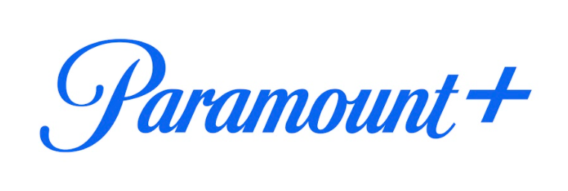

**SPOILERS BELOW**

PARAMOUNT+’S “RUPAUL’S DRAG RACE ALL STARS” INDUCTS NEW QUEEN INTO THE
“DRAG RACE HALL OF FAME” IN EPIC FINALE

Click HERE for Image of the Winner

Sept. 2, 2021 – Paramount+, the streaming service from ViacomCBS, today revealed the winning queen of RUPAUL’S DRAG RACE ALL STARS, during the season six grand finale. The top four queens, Eureka!, Ginger Minj, Kylie Sonique Love and Ra’jah O’Hara, competed in a songwriting maxi-challenge for RuPaul’s new single, “This Is Our Country,” with help from country music icon and GRAMMY® Award-winner Tanya Tucker. In a season full of sickening runway looks, hilarious comedy and jaw-dropping performances, Kylie Sonique Love sashayed her way to the top and was crowned the ALL STARS winner, earning a $100,000 cash prize, fulfilling the ultimate ru-demption and cementing a coveted spot in the “Drag Race Hall of Fame.”

“Kylie’s exhilarating blend of tenacity, vulnerability and talent made her a sizzling stand-out in the most compelling ALL STARS in the franchise’s herstory,” said five-time Emmy® Award-winning host and executive producer RuPaul. “Her trajectory from season two of DRAG RACE to the winner of ALL STARS 6 is an inspiration to all who have had the privilege of sharing her amazing journey. All hail Queen Kylie!”

“I couldn’t have done this without thanking the universe every single day, for all my blessings and all the people around me that believed in my dreams,” said ALL STARS winner Kylie Sonique Love. “I’m so grateful to Paramount+, World of Wonder and RuPaul for taking everything she’s learned in the business and for giving people like me an opportunity. Not just drag queens but trans people, and I’m so grateful to be the first trans representation with the crown.”

Fans can catch up on the full action-packed seasons of RUPAUL’S DRAG RACE ALL STARS and RUPAUL’S DRAG RACE ALL STARS UNTUCKED, both streaming exclusively on Paramount+.

For more information on RUPAUL’S DRAG RACE ALL STARS and up-to-date news, go to www.vh1press.com. Join the conversation by using #DragRace and #AllStars6 and follow the official accounts on Instagram, Twitter, Facebook, YouTube and TikTok. RUPAUL’S DRAG RACE ALL STARS and RUPAUL’S DRAG RACE ALL STARS UNTUCKED are produced by VH1 and World of Wonder.

About Paramount+:
Paramount+, a direct-to-consumer digital subscription video on-demand and live streaming service from ViacomCBS, combines live sports, breaking news, and a mountain of entertainment. The premium streaming service features an expansive library of original series, hit shows and popular movies across every genre from world-renowned brands and production studios, including BET, CBS, Comedy Central, MTV, Nickelodeon, Paramount Pictures and the Smithsonian Channel. The service is also the streaming home to unmatched sports programming, including every CBS Sports event, from golf to football to basketball and more, plus exclusive streaming rights for major sports properties, including some of the world’s biggest and most popular soccer leagues. Paramount+ also enables subscribers to stream local CBS stations live across the U.S. in addition to the ability to stream ViacomCBS Streaming’s other live channels: CBSN for 24/7 news, CBS Sports HQ for sports news and analysis, and ET Live for entertainment coverage.

For more information about Paramount+, please visit www.paramountplus.com and follow @ParamountPlus on social platforms.

About World of Wonder:
For nearly three decades, award-winning media company World of Wonder has introduced audiences to new worlds, talent and ideas that have shaped culture. A pioneer in both scripted and documentary formats across television, film and digital platforms, WOW’s prolific portfolio includes the global phenomenon, Emmy-award winning “RuPaul’s Drag Race” franchise (VH1/Logo/WOW Presents Plus), “Million Dollar Listing” LA & NY (Bravo), and “Big Freedia: Queen of Bounce” (Fuse.) WOW’s rich documentary filmmaking pedigree includes premiering seven projects at Sundance Film festival and numerous productions for networks including HBO, E!, BBC, and theatrical release through WOW Docs. Notable film projects include “Mapplethorpe: Look at the Pictures,” “Party Monster,” and “The Eyes of Tammy Faye.” World of Wonder has also created a substantial digital footprint with its owned-and-operated streaming service WOW Presents Plus and YouTube channel WOWPresents. The extended World of Wonder-verse includes music label World of Wonder Records, WOW Podcast Network, and the world’s largest drag culture convention RuPaul’s DragCon. Co-founders Randy Barbato and Fenton Bailey have been named to Variety’s Reality TV Impact Report, honored with the IDA Pioneer Award, named to Realscreen’s Global 100 list, and selected for the OUT100 list for their trailblazing work. World of Wonder creates out of a historic building/gallery space in the heart of Hollywood.

* * *

MTV Entertainment Studios Press Contacts:
Michael Fabiani, Michael.Fabiani@viacomcbs.com
Marteena Oliphant, Marteena.Oliphant@viacomcbs.com
Mariana Garces, Mariana.Garces@viacomcbs.com

Paramount+ Press Contacts:
Kate Mann, kate.mann@cbsi.com
Natalie Speck, natalie.speck@cbsi.com

MPRM Press Contact:
Emily Merkley, viacom@mprm.com

Photo Contact:
Nancy Eichenbaum, nancy.eichenbaum@cbsinteractive.com

