DRAMA SERIES “COYOTE” TO DEBUT EXCLUSIVELY ON
CBS ALL ACCESS ON JAN. 7

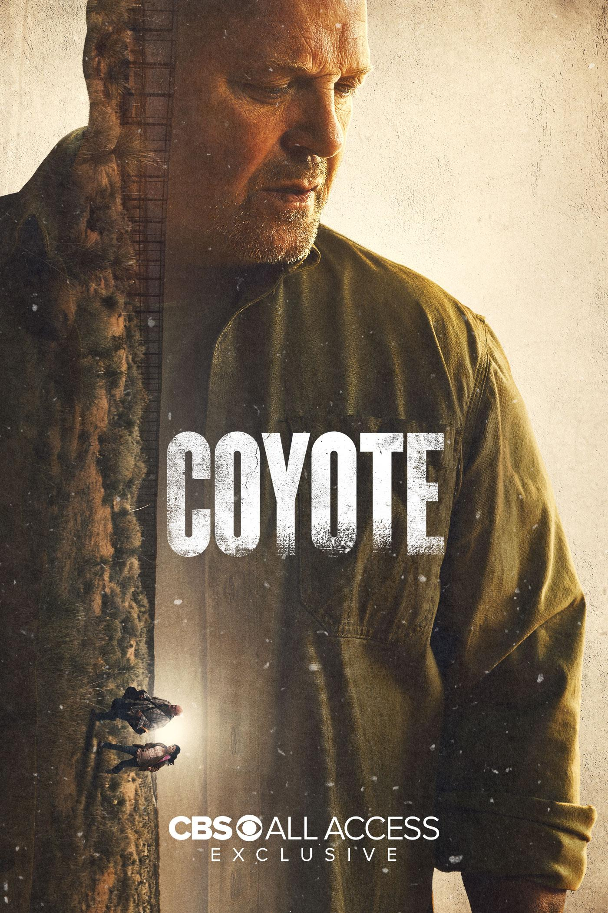

“Coyote” Official Trailer Released Today

All Episodes of “Coyote” Will Be Available to Binge Beginning Jan. 7
Only on CBS All Access

Series Produced by Sony Pictures Television

Nov. 19, 2020 – CBS All Access, ViacomCBS’ digital subscription video on-demand and live streaming service, today released the official trailer for the series, and announced all six episodes of the scripted drama series COYOTE, starring Emmy® Award-winner Michael Chiklis, Juan Pablo Raba and Adriana Paz, will be available to stream exclusively on the service beginning Thursday, Jan. 7.

COYOTE is the story of Ben Clemens (Chiklis), who after 32 years as a border patrol agent is forced to work for the very people he spent his career trying to keep out of America. Now exposed to life on the other side of the wall, Ben will start to question his black and white views of the world, challenging his ideology and his loyalties.

In addition to Michael Chiklis and Juan Pablo Raba, who plays Juan Diego “El Catrin” Zamora, the head of a small family cartel in Mexico, the series also stars Adriana Paz, Kristyan Ferrer, Octavio Pisano, Cynthia Kaye McWilliams, Julio Cedillo and introducing Emy Mena.

Emmy® Award-winning executive producer Michelle MacLaren (“Game of Thrones,” “Breaking Bad”) directed the series premiere and second episode and serves as an executive producer on the series. David Graziano (“American Gods,” “Southland”) serves as showrunner. Co-creators Graziano, Michael Carnes and Josh Gilbert (“Mr. Woodcock”) also serve as executive producers and writers on the series. Dark Horse Entertainment’s Mike Richardson and Keith Goldberg (“The Umbrella Academy”), Rebecca Hobbs of MacLaren Entertainment, and Michael Chiklis also serve as executive producers.

About CBS All Access:
CBS All Access is ViacomCBS’ direct-to-consumer digital subscription video on-demand and live streaming service. CBS All Access gives subscribers the ability to watch more than 20,000 episodes and movies on demand – including exclusive original series, current and past seasons of hit shows from the CBS Television Network and growing libraries from brands across the ViacomCBS portfolio including BET, Comedy Central, MTV, Nickelodeon, Smithsonian and more, as well as a wealth of films from Paramount Pictures. The service is also the streaming home to unmatched sports programming, including every CBS Sports event, from golf to football to basketball and more, plus exclusive streaming rights for major sports properties, including some of the world’s biggest and most popular soccer leagues. CBS All Access also enables subscribers to stream local CBS stations live across the U.S. in addition to the ability to stream ViacomCBS Digital’s other live channels: CBSN for 24/7 news, CBS Sports HQ for sports news and analysis, and ET Live for entertainment coverage.

The service is currently available across all major device platforms including online, mobile and connected TV and OTT platforms and services. Versions of CBS All Access have launched internationally in Canada and Australia (10 All Access), with unique but similar content and pricing plans. For more details on CBS All Access, please visit https://www.cbs.com/all-access.

About Dark Horse Entertainment
Founded by Mike Richardson, Dark Horse Entertainment was spun off from his publishing company, Dark Horse Comics, in 1992. The company’s first major hits —THE MASK and TIMECOP — were based on Richardson’s creations and DHE has since produced over 30 films and series, including an Emmy Award-winning documentary, MR. WARMTH: THE DON RICKLES PROJECT. Recent projects include the DARK MATTER television series for Syfy network, and the hit Netflix film, POLAR, adapted from Victor Santo’s noir graphic novel starring Mads Mikkelsen. Current projects include the second season of THE UMBRELLA ACADEMY, a Netflix original series based on the comics created by Gerard Way (My Chemical Romance) and Gabriel Bá, and RESIDENT ALIEN, a television series for Syfy starring Alan Tudyk (Firefly) based on the comic series by Peter Hogan and Steve Parkhouse.

About Sony Pictures Television
Sony Pictures Television (SPT) is one of the television industry’s leading content providers, producing, distributing and carrying programming worldwide in every genre and for every platform. In addition to managing one of the industry’s largest libraries of award-winning feature films, television shows and formats, SPT is home to a thriving global content business, operating a robust portfolio of wholly-owned and joint-venture production companies across the U.S., Europe, Latin America, and Asia Pacific, as well as linear and digital channels around the world. SPT is a Sony Pictures Entertainment Company.

* * *

CBS All Access Press Contacts:
Morgan Seal | 646-424-4321 | morgan.seal@cbsi.com
Natalie Speck | 212-380-0299 | natalie.speck@cbsi.com

Photo Contact:
Sarah Coulter | 216-633-5449 | sarah.coulter@cbsi.com

Sony Pictures Television Press Contact:
Amanda Muñoz-Temple | 424-345-6016 | amanda_munoz-temple@spe.sony.com

