
KERRICE BROOKS, BELLA SHEPARD AND GEORGE HAWKINS
JOIN THE PARAMOUNT+ ORIGINAL SERIES
STAR TREK: STARFLEET ACADEMY

The All-New Original Series from CBS Studios Will Follow
the Adventures of a New Class of Starfleet Cadets

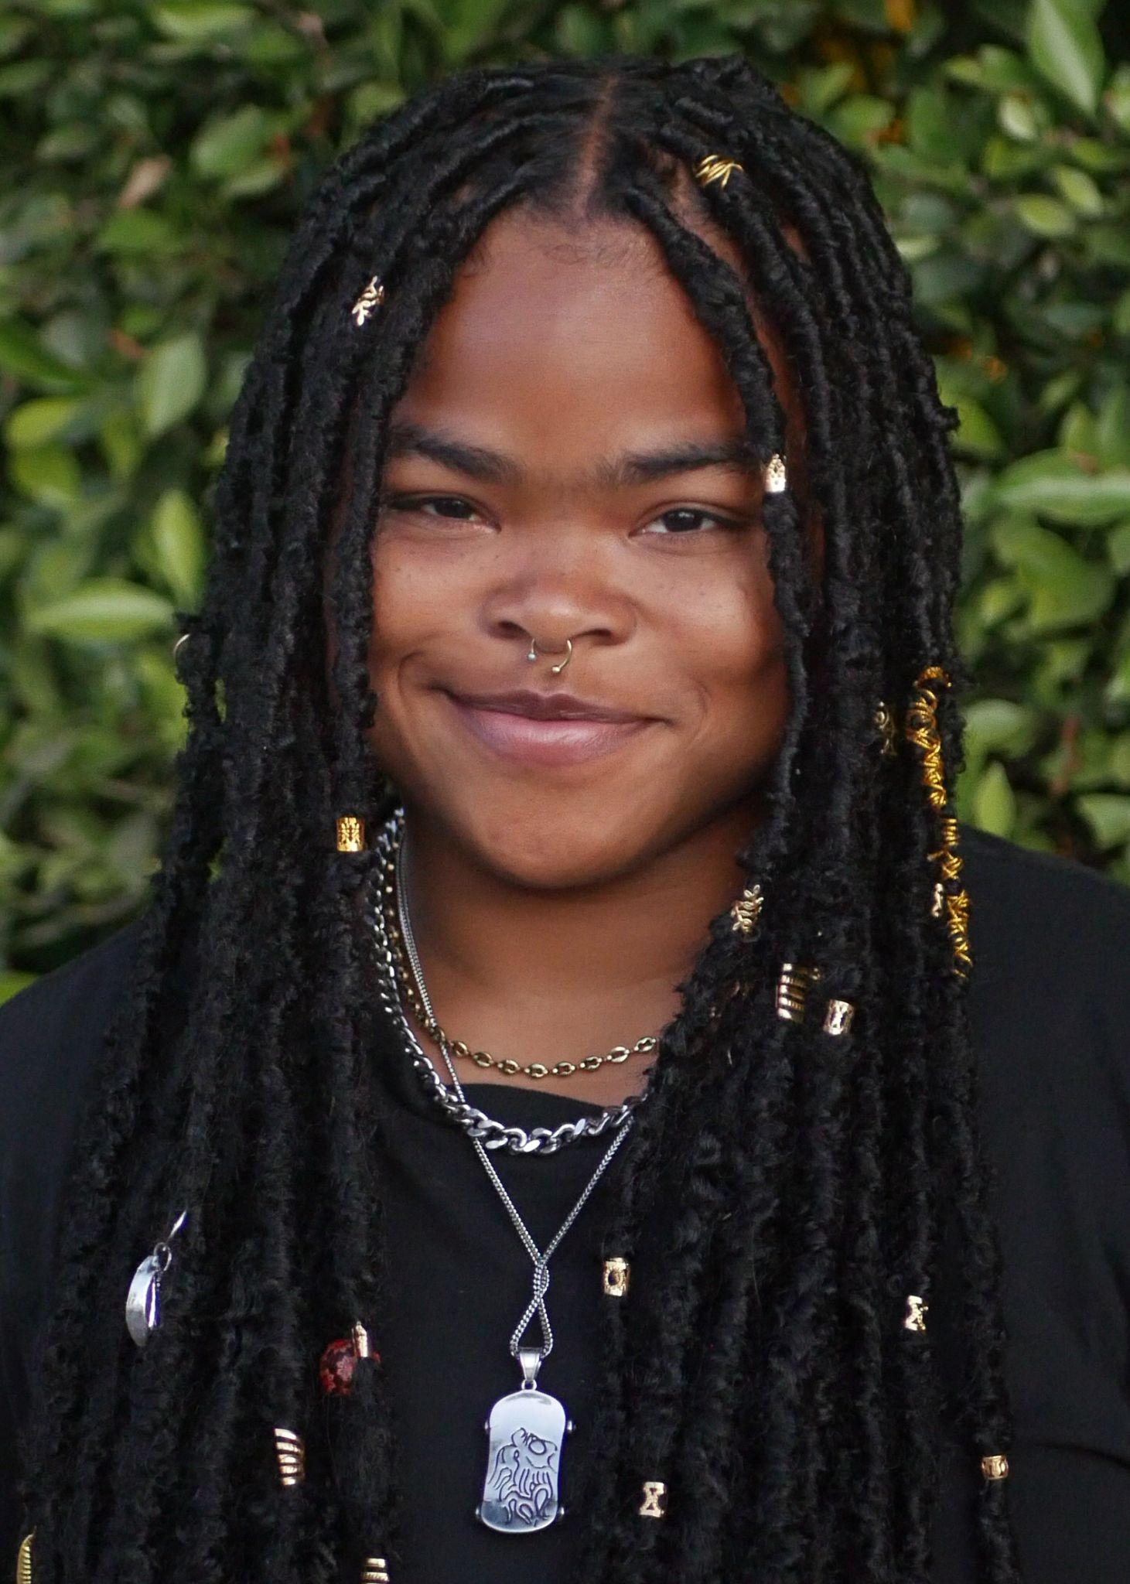
l-r: Kerrice Brooks (photo credit, K. Brooks), Bella Shepard (photo credit, David Muller) and George Hawkins (photo credit, Yellowbelly)

Headshots HERE

July 9, 2024 – Paramount+ today announced that Kerrice Brooks (My Old Ass), Bella Shepard (Wolf Pack) and George Hawkins (Tell Me Everything) have joined the cast of the original series STAR TREK: STARFLEET ACADEMY. The upcoming series will follow the adventures of a new class of Starfleet cadets as they come of age in one of the most legendary places in the galaxy. Produced by CBS Studios, the new series will begin production later this summer.

Brooks, Shepard and Hawkins will play cadets, joining previously announced cast members Holly Hunter as the captain and chancellor of Starfleet Academy and Paul Giamatti as the season’s villain.

STAR TREK: STARFLEET ACADEMY introduces viewers to a young group of cadets who come together to pursue a common dream of hope and optimism. Under the watchful and demanding eyes of their instructors, they discover what it takes to become Starfleet officers as they navigate blossoming friendships, explosive rivalries, first loves and a new enemy that threatens both the Academy and the Federation itself.

Brooks, an actress and professional dancer, will make her feature film debut this year in My Old Ass produced by Margot Robbie and directed by Megan Park. She will also star in the 70s coming-of-age comedy, Feeling Randy. Brooks' credits include The Prom, The Cypher, How We Roll and On My Block. Brooks got her start in the entertainment industry as a professional dancer performing with elite artists including Billie Eilish, Kanye West, Lil’ Nas, Kelly Rowland and more.

Shepard was recently the lead of the Paramount+ Series, Wolf Pack and is best known for her previous Brat Series’ On the Ropes and A Girl Named Jo, and as the lead in the series, Two Sides. Shepard was also seen in The Wilds, Witch Hunt,, and the iCARLY reboot . She also had a lead guest role on the final season of Orange Is the New Black, and recurring roles on Life in Pieces and Grace and Frankie.

Hawkins is best known for playing Dylan in Tell Me Everything. His previous credits include Sean in the BAFTA-nominated film Boiling Point and Adam in the feature film Gassed Up. In 2023, Hawkins graduated from London’s Mountview Academy of Theatre Arts.

Alex Kurtzman and Noga Landau serve as co-showrunners and executive produce the series alongside executive producers Gaia Violo, Aaron Baiers, Olatunde Osunsanmi, Jenny Lumet, Rod Roddenberry, Trevor Roth, Frank Siracusa and John Weber. The series’ premiere episode is written by Gaia Violo. STAR TREK: STARFLEET ACADEMY is produced by CBS Studios in association with Secret Hideout and Roddenberry Entertainment. The series is distributed by Paramount Global Content Distribution.

STAR TREK: STARFLEET ACADEMY is the latest addition to the expanding STAR TREK franchise on Paramount+, which also includes the fifth and final season of STAR TREK: DISCOVERY, STAR TREK: STRANGE NEW WORLDS, the animated series STAR TREK: LOWER DECKS and STAR TREK: SECTION 31, an original movie with Oscar® winner Michelle Yeoh.
About Paramount+
Paramount+, part of Paramount’s (Nasdaq: PARA, PARAA) global portfolio of multimedia entertainment and news brands, is a direct-to-consumer digital subscription video on-demand and live streaming service, combining live sports, breaking news and A Mountain of Entertainment™. The streaming service features an expansive library of original series, hit shows and popular movies across every genre from world-renowned brands and production studios, including BET, CBS, Comedy Central, MTV, Nickelodeon, Paramount Pictures and the Smithsonian Channel. Paramount+ with SHOWTIME®, the service's cornerstone plan, is also home to SHOWTIME® content, including scripted hits and critically acclaimed nonfiction projects and films. This premium plan includes unmatched events and sports programming through the local live CBS stream, including golf, basketball and more. All Paramount+ subscribers have streaming access to CBS News Network for 24/7 news and CBS Sports HQ for sports news and analysis.

For more information about Paramount+, please visit www.paramountplus.com, and follow @ParamountPlus on social media.

About CBS Studios
CBS Studios is one of the world’s leading suppliers of entertainment programming with development and production for broadcast, cable networks, streaming services, and other emerging platforms. The Studio’s expansive portfolio spans a diverse slate of commercially successful and critically acclaimed scripted programming, which includes genre-defining franchises such as NCIS and the ever-growing Star Trek universe, award-winning late night and daytime talk shows, as well as an extensive library of iconic intellectual property. The Studio also develops and produces local language and international content originating outside of the US for viewers around the world.

***

PRESS CONTACTS

Paramount+ Press Contacts:
Nikki Kozel: Nikki.Kozel@paramount.com
Mackenzie Lawn: Mackenzie.Lawn@paramount.com

CBS Studios Press Contact:
Jennifer Verti: Jennifer.Verti@viacomcbs.com

