

FINESTKIND OFFICIAL TRAILER AND KEY ART RELEASED AHEAD OF THE ORIGINAL FILM’S DECEMBER 15 PREMIERE
ON PARAMOUNT+

Written and Directed by Oscar® Winner Brian Helgeland, The Crime Drama
Stars Ben Foster, Toby Wallace, Jenna Ortega and Tommy Lee Jones

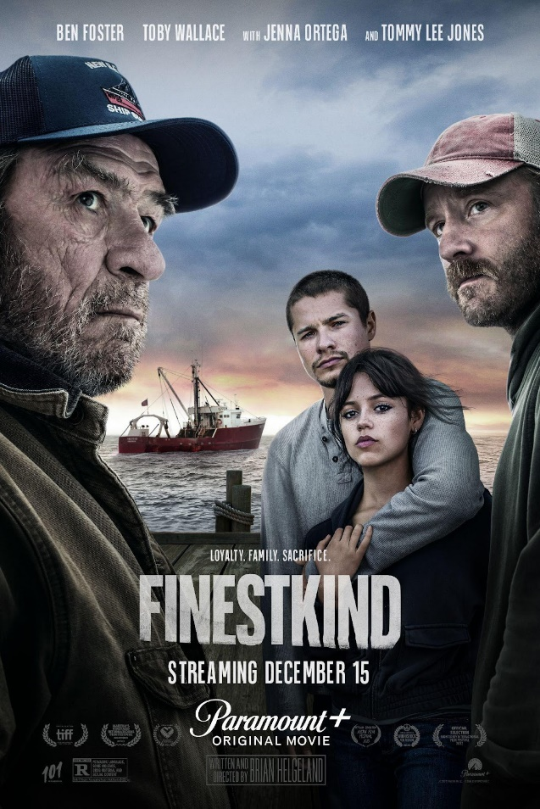

View Official Trailer Here

Download Key Art and Film Imagery Here

October 26, 2023 – Paramount+ today debuted the official trailer and key art for Oscar winner Brian Helgeland’s original film FINESTKIND. The crime drama, starring Independent Spirit Award winner Ben Foster, Toby Wallace, Emmy®-nominee Jenna Ortega and Oscar-winner Tommy Lee Jones, will premiere on Friday, December 15, on Paramount+ in the U.S. and Canada. FINESTKIND also will debut in all Paramount+ international markets on December 16, and 101 Studios is handling international sales for all remaining markets.

FINESTKIND tells the story of two brothers (Foster and Wallace), raised in different worlds, who are reunited as adults over a fateful summer. Set against the backdrop of commercial fishing, the story takes on primal stakes when desperate circumstances force the brothers to strike a deal with a violent Boston crime gang. Along the way, a young woman (Ortega) finds herself caught perilously in the middle. Sacrifices must be made, and bonds between brothers, friends, lovers, and a father (Jones) and his son are put to the ultimate test.

Also starring Ismael Cruz Cordova, Aaron Stanford, Scotty Tovar, Tim Daly, Lolita Davidovich and Clayne Crawford, FINESTKIND is produced by Gary Foster and Russ Krasnoff of Krasnoff/Foster Entertainment, Oscar nominee Taylor Sheridan of Bosque Ranch, David C. Glasser of 101 Studios and in association with MTV Entertainment Studios. The film is executive produced by Jennifer Roth, Ron Burkle, David Hutkin and Bob Yari and co-produced by Joseph Micucci.
For more information about Paramount+ and FINESTKIND, please visit www.paramountplus.com and follow @ParamountPlus on Instagram, X, TikTok and Facebook.
***
About Paramount+
Paramount+, a direct-to-consumer digital subscription video on-demand and live streaming service, combines live sports, breaking news and A Mountain of Entertainment™. The streaming service features an expansive library of original series, hit shows and popular movies across every genre from world-renowned brands and production studios, including BET, CBS, Comedy Central, MTV, Nickelodeon, Paramount Pictures and the Smithsonian Channel. Paramount+ with SHOWTIME®, the service's cornerstone plan, is also home to SHOWTIME® content including scripted hits, critically acclaimed nonfiction projects, SHOWTIME SPORTS® (including industry-leading SHOWTIME Boxing®) and films. This premium plan includes unmatched events and sports programming through the local live CBS stream, including golf to basketball and more. All Paramount+ subscribers have streaming access to CBS News Network for 24/7 news and CBS Sports HQ for sports news and analysis.
For more information about Paramount+, please visit www.paramountplus.com and follow @ParamountPlus on social platforms.

About 101 Studios
101 Studios is a global entertainment company dedicated to the acquisition, financing, development, production and distribution of high-caliber, creator-driven content. With an unmatched television slate partnered with outstanding filmmakers and talent, 101 Studios productions include the award-winning series Yellowstone, George & Tammy and 1883. We also produce some of the most critically acclaimed shows, such as 1923, MAYOR OF KINGSTOWN, TULSA KING and SPECIAL OPS: LIONESS. Upcoming projects include LAWMEN: BASS REEVES and LAND MAN.

Building upon this success, 101 Studios’ Unscripted Division works with talented storytellers in bringing their vision to life. Some of these projects include Amazon Prime documentary Kickback which is an expose on the corruption inside the largest sport’s organization in the world: FIFA; The Last Cowboy, a documentary on the high stakes world of professional horse reining, and the upcoming HBO docuseries about the sexual abuse and cover-up at Ohio State University, co-produced by George Clooney and Grant Heslov's Smokehouse Pictures. On the scripted film side, past releases include the Sundance Audience award winner Burden, as well as the family comedy The War With Grandpa, the historical drama The Current War: Director's Cut and the upcoming FINESTKIND. 101 Studios advocates for first-class collaboration and innovation. As an example we are partnered with iHeartRadio and Sports Illustrated Studios on the Ambie nominated podcast Choosing Sides: F1. 101 Studios also produces high-profile sports content under its own label, 101 Sports. Additionally, 101 Studios' Brand Division increases the exposure for the properties of our partners to millions across the world.

***
Paramount+ Press Contacts
Morgan Seal – Morgan.Seal@paramount.com
Tiffany Girardi – Tiffany.Girardi@paramount.com
Kate Mann – Kate.Mann@paramount.com
Natalie Speck – Natalie.Speck@paramount.com
Amy Wesson – Amy.Wesson@paramount.com

101 Studios Press Contact:
Dani Weinstein – DWeinstein@101studios.com

