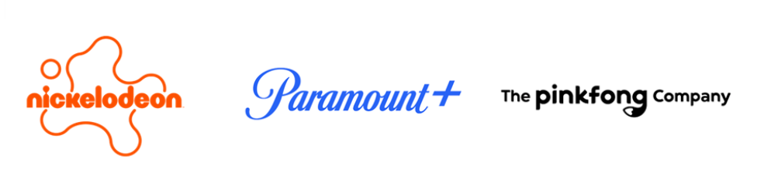

NICKELODEON, PARAMOUNT+ AND PINKFONG REVEAL OFFICIAL TRAILER FOR ORIGINAL ANIMATED MUSICAL ADVENTURE BABY SHARK’S BIG MOVIE, PREMIERING FRIDAY, DEC. 8, ON NICKELODEON AND PARAMOUNT+

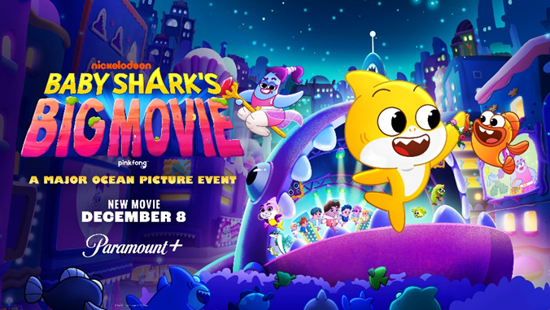
BABY SHARK’S BIG MOVIE Music Album, Featuring Original Songs From Feature-Length Film, Set for Release on Friday, Dec. 8
Season One of “Baby Shark’s Big Show!” is Now Streaming
On Paramount+
Click HERE to Watch the Official Trailer

Click HERE to Download Key Art

November 14, 2023 – Nickelodeon, Paramount+ and The Pinkfong Company today released the official trailer and key art for BABY SHARK’S BIG MOVIE, the first-ever feature-length original animated movie based on the globally beloved preschool property. The upcoming fin-tastic musical adventure is set to debut Friday, December 8, at 12 p.m. (ET/PT) on Nickelodeon and stream on Paramount+ in the U.S. and Canada, and the following day in the UK and Australia. The family-friendly film will debut in additional Paramount+ international markets, where the service is available, in 2024. In Korea, Southeast Asia and China, BABY SHARK’S BIG MOVIE is distributed by The Pinkfong Company. The film will be featured in the Paramount+ Holiday Collection that features fan favorite festive movies and iconic seasonal episodes from beloved series for the whole family.
Co-produced by Nickelodeon Animation and The Pinkfong Company and directed by Daytime Creative Arts Emmy® winner Alan Foreman (The Casagrandes, Welcome to the Wayne), the movie follows Baby Shark and his family as they move to Chomp City – the big city of sharks.
Fans will be able to sing and dance along to original songs from BABY SHARK’S BIG MOVIE, including the previously released “It’s Stariana!” and “Keep Swimmin’ Through” singles, with the release of the film’s official soundtrack on Friday, Dec. 8. Released through a partnership with Sony Music Entertainment UK’s Relentless Records, the BABY SHARK’S BIG MOVIE soundtrack album will be available globally on all music streaming platforms, including Apple Music, Amazon Music, Spotify, YouTube Music and more. Music for BABY SHARK’S BIG MOVIE was composed by Jon Chau. Songs were written and produced by Matthew Tishler, Andrew Underberg, Chen Neeman, Doug Rockwell, Tova Litvin and Pinkfong. The track list is as follows:
- Baby Shark (Movie Version)
- It’s Stariana!
- Peak Fin-ship
- Keep Swimmin’ Through
- Dive On In
- It’s Stariana! (Sea Me Now)
- Peak Fin-ship Reprise
- Oceans Apart
- It's My Ocean x Baby Shark (Finale) Mashup
- Nothin's Gonna Beat Our Fin-ship
- Keep Swimmin’ Through x Baby Shark (Dance Remix)
- It's My Ocean
- Baby Shark (Finale)
BABY SHARK’S BIG MOVIE features a jaw-some lineup of guest voice actors, including: actress, singer and producer Ashley Tisdale (Phineas and Ferb the Movie: Candace Against the Universe, High School Musical) as Stariana, a sharp-witted and manipulative, rising pop starfish who wants to take center stage with a splash hit; Aparna Nancherla (Mira, Royal Detective) as Gillie, a charmingly chaotic, bumbling boxfish and Stariana’s assistant; Ego Nwodim (Saturday Night Live) as Leah, a lantern shark and Mommy Shark’s best friend from college; Chloe Fineman (Saturday Night Live, Father of the Bride) as Lannie, Leah’s hyper, lovable daughter; ENHYPEN as an underwater powerhouse K-pop band of belugas; and Lance Bass as TV announcer Lance Bass.
The new voice actors join the swim-sational lineup of series regulars from Baby Shark’s Big Show!, including: Kimiko Glenn (Orange Is the New Black) as Baby Shark; Luke Youngblood (Harry Potter and the Sorcerer’s Stone) as William; Natasha Rothwell (Insecure) as Mommy Shark; Eric Edelstein (We Bare Bears) as Daddy Shark; Debra Wilson (MADtv) as Grandma Shark; and Patrick Warburton (Seinfeld) as Grandpa Shark. The film also features returning guest star Grammy®-winning, multi-platinum superstar Cardi B as rap icon Sharki B and her family: Offset as Offshark; Kulture as Kulture Sharki; and newcomer Wave as Wavey Shark.
In BABY SHARK’S BIG MOVIE, Baby Shark is forced to leave behind the world he loves after his family’s move to the big city and must adjust to his new life without his best friend William. When Baby Shark encounters an evil pop starfish named Stariana, who plans to steal his gift of song in order to dominate all underwater music, he must break her spell to restore harmony to the seas.
The first season (26 episodes) of the hit preschool series Baby Shark’s Big Show! is available now to stream on Paramount+. The series launched globally in 2021 across Nickelodeon-branded channels and platforms and is currently in its second season.
​​​Prior to the premiere of BABY SHARK’S BIG MOVIE, kids and families can also dive into this year’s 97th Macy's Thanksgiving Day Parade® on Thursday, Nov. 23, to see Nickelodeon and Pinkfong’s Baby Shark float featuring an underwater seascape that includes members of the Shark family who will bring their own special brand of aquatic holiday cheer. Showcasing a special performance by ENHYPEN of their single “Keep Swimmin’ Through” from the movie, the 18-foot-long float will also be followed by a larger-than-life 25-foot-long Baby Shark balloon.
“Pinkfong’s Baby Shark” launched on YouTube in November 2015 and took the world by storm and became the world’s first-ever video to hit 10 billion views on YouTube, making it the most-viewed video in YouTube history. With music, characters, story and dance all combined together, the song earned RIAA Diamond certification (11x platinum), having sold more than 11 million units in the U.S. and spawned a viral phenomenon, #BabySharkChallenge, which generated more than 1 million cover videos around the globe.
BABY SHARK’S BIG MOVIE is executive produced by Gary “Doodles” DiRaffaele (Breadwinners), Tommy Sica (Breadwinners) and Whitney Ralls (My Little Pony: Equestria Girls), along with Minseok Kim, Ryan Lee and Bin Jeong for The Pinkfong Company. Ralls also serves as writer for the movie. Baby Shark’s Big Show! is executive produced by DiRaffaele, Sica and Ralls. Both BABY SHARK’S BIG MOVIE and Baby Shark’s Big Show! are produced by Nickelodeon Animation in Burbank, Calif., with production overseen by Eryk Casemiro, Executive Vice President, Nickelodeon Animation, Global Series Content. Miriam Ritchie serves as Nickelodeon’s Executive in Charge of Production for BABY SHARK’S BIG MOVIE and Max Goodman serves as Nickelodeon’s Executive in Charge of Production for Baby Shark’s Big Show!.
About The Pinkfong Company
The Pinkfong Company is a global entertainment company that delivers content and entertaining experiences around the world. Driven by award-winning brands and IPs, the company has created and distributed a range of content across genres and formats including original animated series, world live tours, interactive games, and more. Believing in the power of entertaining and engaging content, The Pinkfong Company is committed to connecting people around the world and bringing joy and inspiration to worldwide audiences of all ages. For more information, please visit our website or follow the company on LinkedIn.

About Paramount+
Paramount+, a direct-to-consumer digital subscription video on-demand and live streaming service, combines live sports, breaking news and A Mountain of Entertainment™. The streaming service features an expansive library of original series, hit shows and popular movies across every genre from world-renowned brands and production studios, including BET, CBS, Comedy Central, MTV, Nickelodeon, Paramount Pictures and the Smithsonian Channel. Paramount+ with SHOWTIME®, the service's cornerstone plan, is also home to SHOWTIME® content including scripted hits, critically acclaimed nonfiction projects, SHOWTIME SPORTS® (including industry-leading SHOWTIME Boxing®) and films. This premium plan includes unmatched events and sports programming through the local live CBS stream, including golf to basketball and more. All Paramount+ subscribers have streaming access to CBS News Network for 24/7 news and CBS Sports HQ for sports news and analysis.

About Nickelodeon
Nickelodeon, now in its 44th year, is the number-one entertainment brand for kids. It has built a diverse, global business by putting kids first in everything it does. The brand includes television programming and production in the United States and around the world, plus consumer products, digital, location-based experiences, publishing and feature films. For more information or artwork, visit http://www.nickpress.com. Nickelodeon is a part of Paramount’s (Nasdaq: PARA, PARAA) global portfolio of multimedia entertainment brands.

Facebook/Twitter/Instagram: @ParamountPlus @nickelodeonfamily @Nickelodeon @pinkfong.official @babyshark_global​
#ParamountPlus
***
Paramount+ Press Contacts:
Morgan Seal – Morgan.Seal@paramount.com
Tiffany Girardi - Tiffany.Girardi@paramount.com
Kylie Burnett – Kylie.Burnett@paramount.com

Paramount+ Press International Contacts:
Christine Woo – Christine.Woo@paramount.com
Debbie Bonora – Debbie.Bonora@paramount.com

Nickelodeon Press Contacts:
Maggie Wang – Maggie.Wang@nick.com
Rachel Volpicello – Rachel.Volpicello@nick.com

