

Nov. 18, 2022

BELLATOR MMA SET TO MAKE NETWORK TELEVISION DEBUT ON CBS SATURDAY, FEB. 4, 2023

“BELLATOR 290” Headlined by Heavyweight World Champion Ryan Bader Defending His Title Against MMA Heavyweight G.O.A.T. Fedor Emelianenko; Plus, #4-Ranked Yoel Romero Set to Face Winner of Tonight’s BELLATOR Light Heavyweight World Championship Fight in Co-Main Event

Live on Primetime CBS and Streaming on Paramount+ from the Kia Forum in Inglewood, Calif.

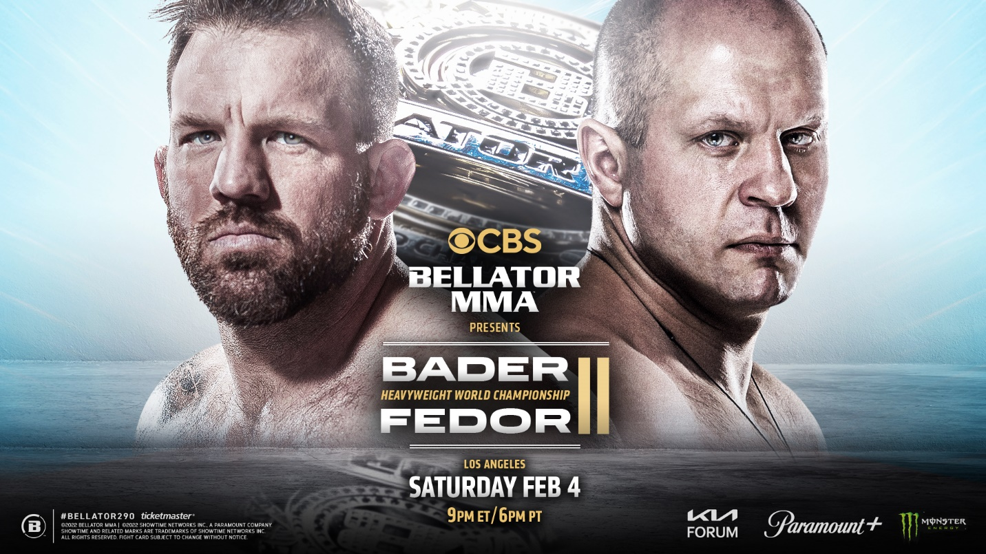

LOS ANGELES – The CBS Television Network and BELLATOR MMA jointly announced today that the first BELLATOR event of 2023 will air on CBS, America’s most-watched television network. The announcement marks the first network television event for BELLATOR, one of the world’s leading mixed martial arts promotions. The event will be headlined by undisputed Heavyweight World Champion Ryan Bader (30-7, 1 NC) defending his title against MMA legend Fedor Emelianenko (40-6, 1 NC) in a rematch of their 2019 Heavyweight World Grand Prix bout. In the co-main event, a second title will be up for grabs as #4-ranked light heavyweight Yoel “Soldier of God” Romero (15-6) will challenge the winner of tonight’s BELLATOR 288 main event between 205-pound World Champion Vadim Nemkov (15-2, 1 NC) and #1-ranked challenger Corey Anderson (16-5, 1 NC).

BELLATOR 290: BADER VS. FEDOR 2 takes place on Saturday, Feb. 4, 2023, at the Kia Forum in Inglewood, Calif. The main card will air live beginning at 9:00 PM, ET/6:00 PM, PT on the CBS Television Network and will be available to stream live and on demand on Paramount+*. BELLATOR, CBS and Paramount+ are all owned by Paramount.

*Paramount+ Premium subscribers will have access to stream live via the live feed of their local CBS affiliate on the service as well as on demand. Essential-tier subscribers of Paramount+ and SHOWTIME subscribers will have access to on-demand following the live presentation.

The last live broadcast of mixed martial arts on CBS was in 2010 from STRIKEFORCE, a global MMA promotion founded by BELLATOR president Scott Coker. The Network aired five MMA events in total from 2008 to 2010.

In their initial matchup at the same arena on Jan. 26, 2019, Bader captured the 265-pound crown by defeating Emelianenko in just 35 seconds during the finale of the BELLATOR Heavyweight World Grand Prix. After flooring the Russian icon by landing a devastating left hand to Emelianenko’s head, Bader followed up with a barrage of punches before referee Mike Beltran stopped the contest.

“We have been working tirelessly on growing this brand into the global powerhouse it is today and a primetime slot on CBS has always been one of our key objectives,” said Coker. “With a healthy roster full of many of the world’s very best fighters, along with elite up-and-coming prospects and legends of the game, I’m very excited to showcase this event on the most-watched network in America.”

Tickets for BELLATOR 290: Bader vs. Fedor 2 will go on sale Friday, Dec. 2, with a special presale starting Wednesday, Nov. 30.

Additional bouts for both the main and preliminary fight cards to be announced.

Returning to the heavyweight division following an impressive run in the BELLATOR Light Heavyweight World Grand Prix, Bader is fresh off a successful BELLATOR MMA World Heavyweight Title defense as he recorded a unanimous decision over Cheick Kongo in a rematch on May 6 in Paris. A former two-division champion, Bader has defeated 10 of his last 12 opponents at both heavyweight and light heavyweight. Fighting out of Chandler, Ariz., the former two-time NCAA Division I All-American wrestler from Arizona State University opened his professional career by winning season eight of “The Ultimate Fighter.”

Never one to shy away from an opponent, Bader has had nothing but high-profile bouts since signing with BELLATOR MMA in 2017, defeating Emelianenko, King Mo, Matt Mitrione, Linton Vassell, Lyoto Machida and Phil Davis. In his initial 265-pound title defense against Kongo, Bader controlled the action before referee Mike Beltran stopped the contest due to an accidental poke to Kongo’s left eye at 3:52 of the opening round.

Widely regarded as the greatest heavyweight in mixed martial arts history, Emelianenko returns to the BELLATOR cage for the second time since his dominant first-round TKO over Quinton “Rampage” Jackson in 2019. In his last outing and first fight in his home country of Russia in five years, Emelianenko headlined BELLATOR MMA 269 and scored a first-round knockout over Tim Johnson on Oct. 23, 2021, in Moscow.

During an illustrious career that has seen him earn 31 stoppages in his 40 victories, the former PRIDE FC Heavyweight World Champion and four-time combat sambo world champion put together an eight-year unbeaten streak on his way to becoming an international MMA icon. Additionally, “The Last Emperor” has established Team Fedor, which features several top Russian fighters including BELLATOR’s Light Heavyweight World Champion Vadim Nemkov and BELLATOR’s former Interim Heavyweight Champion Valentin Moldavsky.

Arguably the sport’s biggest free agent signing in 2021, Romero joined BELLATOR to much fanfare. Known throughout the combat sports world for his remarkable athleticism, dynamic wrestling attacks and lethal knockout power, Romero has remained at the top of his class despite entering MMA far later in life than his contemporaries. The Olympic medalist is now set to challenge for the BELLATOR Light Heavyweight World Championship on the heels of devastating back-to-back TKO victories over Alex Polizzi and Melvin Manhoef.

BELLATOR 290: BADER VS. FEDOR 2 MAIN CARD:

CBS and Paramount +
Saturday, Feb. 4, 2023 (9:00 PM, ET/6:00 PM, PT)

Heavyweight World Title Main Event: #C-Ryan Bader (30-7, 1 NC) vs. #3-Fedor Emelianenko (40-6, 1 NC)
Light Heavyweight World Title Co-Main Event: #C-TBD vs. Yoel Romero (15-6)

*Card subject to change.

Please visit Bellator.com for additional information.

Updated schedule of BELLATOR events – click links for updated fight cards
Friday, Nov. 18 // BELLATOR 288: Nemkov vs. Anderson 2 / “Pitbull” vs. Nurmagomedov // Wintrust Arena // Chicago, Ill.
Friday, Dec. 9 // BELLATOR 289: Bantamweight World Grand Prix Semifinals // Mohegan Sun Arena //Uncasville, Conn.
Saturday, Dec. 31 // BELLATOR MMA vs. RIZIN FF // Saitama Super Arena // Saitama, Japan
Saturday, Feb. 4 // BELLATOR 290: Bader vs. Fedor 2 // Kia Forum // Inglewood, Calif.
Friday, Feb. 24 // BELLATOR 291: DUBLIN // 3Arena // Dublin, Ireland

***

About BELLATOR
BELLATOR MMA is a leading global mixed martial arts organization featuring many of the best fighters in the world. Under the direction of veteran fight promoter Scott Coker, BELLATOR events take place in major cities worldwide and can be seen on television in more than 160 countries to an available audience of over one billion people. In the United States, BELLATOR can be seen on SHOWTIME. BELLATOR is comprised of an executive team that includes top industry professionals in television production, live event orchestration, fighter development/relations, venue procurement, sponsorship creation/development, international licensing, marketing, advertising, publicity, and commission relations. BELLATOR is based in Hollywood, Calif. and owned by entertainment giant ViacomCBS, home to the world's premier entertainment brands that connect with audiences through compelling content across television, motion picture, online and mobile platforms.

Press Contacts:

BELLATOR
Danny Brener – (818) 577-8215 – Danny.Brener@bellator.com
C.J. Tuttle – (310) 496-9110 – Christopher.Tuttle@bellator.com

BZA
Michael Fiedel – (954) 614-4121 – MichaelF@bzapr.com
Jim Aguirre – (408) 394-0436 – JimA@bzapr.com

CBS
Phil Gonzales – Phil.Gonzales@viacomcbs.com

