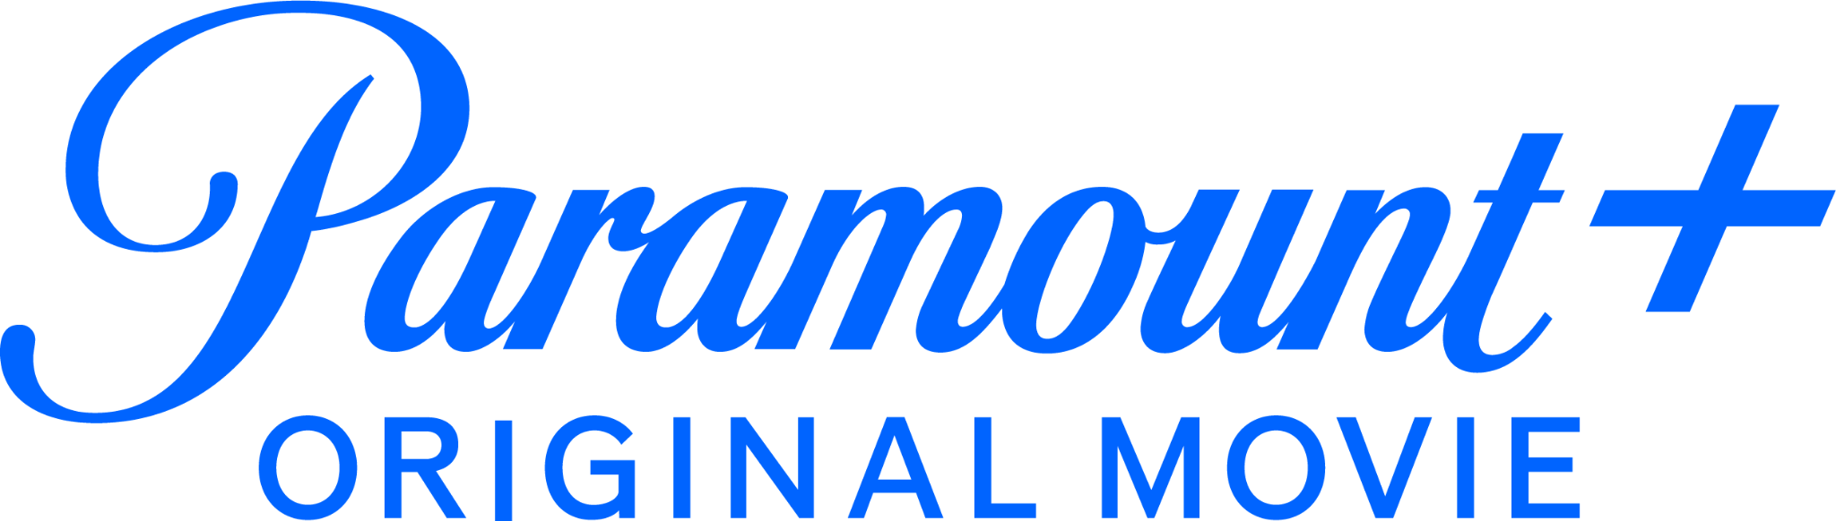

WATCH THE OFFICIAL TRAILER FOR “HONOR SOCIETY,” STARRING ANGOURIE RICE AND GATEN MATARAZZO

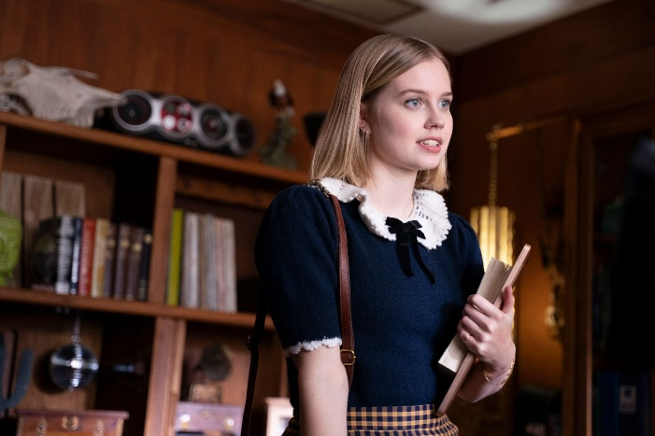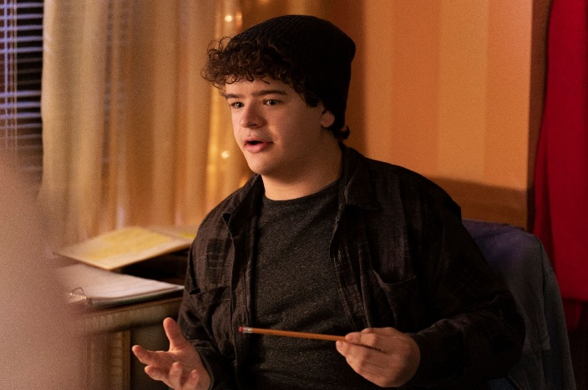
Photo credit: Michael Courtney / Awesomeness/Paramount+

From Awesomeness Films, the Paramount+ Original Film
Premieres July 29, Exclusively on Paramount+

CLICK HERE to Watch the Official Trailer

CLICK HERE to Download New Photos

June 23, 2022 – Paramount+ today released the official trailer and new photos for its upcoming original film, HONOR SOCIETY, a bold YA comedy starring Angourie Rice and Gaten Matarazzo. The film will be available to stream on Friday, July 29, exclusively on Paramount+ in the U.S., Canada, Australia and the U.K., and later this year in Latin America, Italy, Germany, Switzerland, Austria and France.

Honor is an ambitious high school senior whose sole focus is getting into an Ivy League college ... assuming she can first score the coveted recommendation from her guidance counselor, Mr. Calvin. Willing to do whatever it takes, Honor concocts a Machiavellian plan to take down her top three student competitors, until things take a turn when she unexpectedly falls for her biggest competition, Michael.

In addition to Rice and Matarazzo, the cast also includes Christopher Mintz-Plasse, Armani Jackson and Amy Keum.

HONOR SOCIETY is directed by Oran Zegman, with screenplay by David A. Goodman. The film is produced by Michael Lewen and executive produced by Ron French and Don Dunn.

HONOR SOCIETY will stream exclusively on Paramount+ in the U.S., Canada, Australia and the U.K., and will launch later this year in Latin America, Italy, Germany, Switzerland, Austria and France. The film will be distributed by Paramount Global Content Distribution in remaining international markets.

About Paramount+
Paramount+, a direct-to-consumer digital subscription video on-demand and live streaming service, combines live sports, breaking news and a mountain of entertainment. The premium streaming service features an expansive library of original series, hit shows and popular movies across every genre from world-renowned brands and production studios, including BET, CBS, Comedy Central, MTV, Nickelodeon, Paramount Pictures, and the Smithsonian Channel. The service is also the streaming home to unmatched sports programming, including every CBS Sports event, from golf to football to basketball and more, plus exclusive streaming rights for major sports properties, including some of the world’s biggest and most popular soccer leagues. Paramount+ also enables subscribers to stream local CBS stations live across the U.S. in addition to the ability to stream CBSN for 24/7 news, CBS Sports HQ for sports news and analysis, and ET Live for entertainment coverage.

For more information about Paramount+, please visit www.paramountplus.com and follow @ParamountPlus on social platforms.

About Awesomeness
Founded in 2012, Awesomeness is a media company focused on serving the global Gen Z audience through its digital publishing, film and television studio divisions. Awesomeness has become the destination for youth culture, cultivating a loyal audience with award-winning programming on the world’s biggest streaming services including Netflix (smash-hit film series “To All The Boys I’ve Loved Before,” Emmy® winner “Trinkets”) and Hulu (Emmy® winner “Zac & Mia”, Emmy® nominee “Pen15”), along with the company’s immensely popular short-form programs on YouTube (“Next Influencer,” Twin My Heart,” “Noah Beck Tries Things,” “My Dream Quinceañera”), that garner hundreds of millions of views. As a leading media brand, Awesomeness’ worldwide distribution footprint spans owned, social and premium SVOD platforms. Awesomeness is part of Paramount’s (Nasdaq: PARA, PARAA) global portfolio of multimedia entertainment brands and headquartered in Los Angeles, with additional offices in New York.

Facebook/Twitter/Instagram: @ParamountPlus #ParamountPlus

***

Paramount+ Domestic Press Contact:
Kelly Byke – Kelly.Byke@viacomcbs.com

Paramount+ International Press Contacts:
Christina Ringstrom – Christina.Ringstrom@paramount.com
Christine Woo – Christine.Woo@paramount.com

Awesomeness Press Contacts:
Gayle Gaviola – Gayle.Gaviola@paramount.com
Dee Perez – Danaee.Perez@paramount.com

