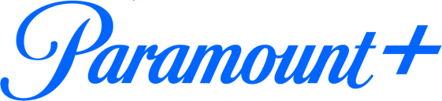

PARAMOUNT+ REVEALS OFFICIAL TRAILER FOR ORIGINAL ANIMATED SERIES “BIG NATE,”
PREMIERING THURSDAY, FEB. 17

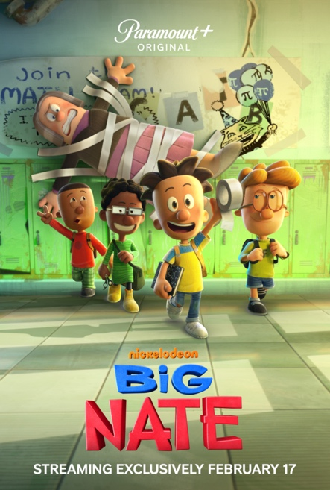

Jack Black Guest Stars in the Series Premiere

Based on the Best-Selling Children’s Books, the All-New Animated Series
Is Produced by Nickelodeon Animation Studio

Watch Exclusive Look of “Big Nate” During Nickelodeon and CBS Sports’
“NFL Wild Card Game” Halftime Presentation Sunday, Jan. 16

Click HERE to Watch Official Trailer

Click HERE to Download Key Art and Series Imagery

Jan. 11, 2021 – Paramount+, the streaming service from ViacomCBS, today released the official trailer and key art for its upcoming animated original series BIG NATE, based on the best-selling children’s books and comic strip written and drawn by acclaimed author and cartoonist Lincoln Peirce. The series will stream beginning Thursday, Feb. 17, exclusively on Paramount+ in the U.S., Canada, Latin America and later in the month in Australia. The first eight episodes will be available in the U.S. and Canada, with more episodes to be announced at a later date. Produced by Nickelodeon Animation Studio, BIG NATE follows a precocious 11-year-old boy named Nate and his best friends as they navigate sixth grade with humor and style.

Nate’s misadventures will begin with an exclusive look at BIG NATE during the halftime presentation of Nickelodeon and CBS Sports’ slime-filled NFL WILD CARD GAME ON NICKELODEON, airing Sunday, Jan. 16 at 4:30 PM, ET.

Paramount+’s BIG NATE will feature brand-new original storylines centered on Nate, a sixth-grade kid who has a never-ending need to prove his awesomeness to the world. Whether he’s dealing with disasters at home or detention at school, Nate Wright is no stranger to a challenge. Luckily, he’s able to express himself through the world of cartoons that he creates. Charming, mischievous and a magnet for misadventure, Nate always finds a way to turn trouble into fun.

In the series premiere, “The Legend of the Gunting,” Nate has multiple detentions on the docket, per usual. But this time he is only one detention away from a fate only whispered about in the halls of P.S. 38. Meanwhile, the unhinged new kid is determined to become Nate’s prank partner. Jack Black (“Jumanji: Welcome to the Jungle”) guest stars as Brad Gunter, a prankster of epic proportions and Nate’s inspiration, and Daniel Jacobs (“All Hail King Julien: Exiled”) lends his voice as Bentley Carter, the new kid at P.S. 38 eager to wreak havoc through the school on teachers and students alike.

The stellar lineup of actors lending their voice talent to the beloved characters of BIG NATE include Ben Giroux (Nate Wright), Dove Cameron (Ellen Wright), Rob Delaney (Martin Wright), Bryce Charles (Dee Dee Holloway), Daniel MK Cohen (Francis Pope), Arnie Pantoja (Teddy Ortiz), Charlie Schlatter (Chad Applewhite), Kevin Michael Richardson (Principal Nichols), Carolyn Hennesy (Mrs. Godfrey), Nik Dodani (Randy), Betsy Sodaro (Kim), Lisa Kay Jennings (Gina), Chandni Parekh (Jenny), Todd Haberkorn (Artur), Ryan Garcia (Mr. Rosa), Mike Rivkin (Mr. Galvin) and Chester Rushing (Zeff).

BIG NATE is executive produced by Mitch Watson (“All Hail King Julien”) and John Cohen (“The Angry Birds Movie”) and produced by Amy McKenna (“Beware the Batman”), with Lincoln Peirce serving as consultant throughout development and production. Bridget McMeel is co-producer.

Peirce’s humor-based books about Nate and his friends have spent more than 150 weeks on the New York Times’ best-seller list. The BIG NATE book series (https://bignatebooks.com/) is published worldwide in 33 languages and available as ebooks and audiobooks and as an app, Big Nate: Comix by U! Additionally, the BIG NATE comic strip is syndicated by Andrews McMeel Syndication and appears in more than 400 newspapers and online daily at www.gocomics.com/bignate. The BIG NATE comic collections are published by Andrews McMeel Publishing, and the BIG NATE novels are published by HarperCollins Children’s Books.

BIG NATE joins Paramount+’s growing lineup of original and exclusive kids’ programming, including STAR TREK: PRODIGY, RUGRATS and KAMP KORAL: SPONGEBOB’S UNDER YEARS, and original movies including THE SPONGEBOB MOVIE: SPONGE ON THE RUN, THE J TEAM, PAW PATROL: THE MOVIE and CLIFFORD THE BIG RED DOG, which recently premiered on the service the same day it hit theaters and set a new record as the service’s most-watched original film.

@ParamountPlus
@Nickelodeon
#BigNate

About Paramount+
Paramount+, a direct-to-consumer digital subscription video on-demand and live streaming service from ViacomCBS, combines live sports, breaking news and a mountain of entertainment. The premium streaming service features an expansive library of original series, hit shows and popular movies across every genre from world-renowned brands and production studios, including BET, CBS, Comedy Central, MTV, Nickelodeon, Paramount Pictures and the Smithsonian Channel. The service is also the streaming home to unmatched sports programming, including every CBS Sports event, from golf to football to basketball and more, plus exclusive streaming rights for major sports properties, including some of the world’s biggest and most popular soccer leagues. Paramount+ also enables subscribers to stream local CBS stations live across the U.S. in addition to the ability to stream ViacomCBS Streaming’s other live channels: CBSN for 24/7 news, CBS Sports HQ for sports news and analysis, and ET Live for entertainment coverage.

For more information about Paramount+, please visit www.paramountplus.com and follow @ParamountPlus on social platforms.

About Nickelodeon:
Nickelodeon, now in its 42nd year, is the number-one entertainment brand for kids. It has built a diverse, global business by putting kids first in everything it does. The brand includes television programming and production in the United States and around the world, plus consumer products, digital, location-based experiences, publishing and feature films. For more information or artwork, visit http://www.nickpress.com. Nickelodeon and all related titles, characters and logos are trademarks of ViacomCBS Inc. (Nasdaq: VIACA, VIAC).

Paramount+ Press Contacts:
Eve Kenny - Eve.Kenny@viacomcbs.com
Magee Snyder - Magee.Snyder@cbsinteractive.com

Nickelodeon Press Contacts:
Katelyn Balach - Katelyn.Balach@nick.com
Molly Neuhauser - Molly.Neuhauser@nick.com

