PARAMOUNT+ AND MTV ENTERTAINMENT STUDIOS GREENLIGHT SEASON TWO OF “THE CHALLENGE: ALL STARS”

An All-Star Lineup of Legendary Vets Make Their Epic Return
Thursday, Nov. 11 Exclusively on Paramount+

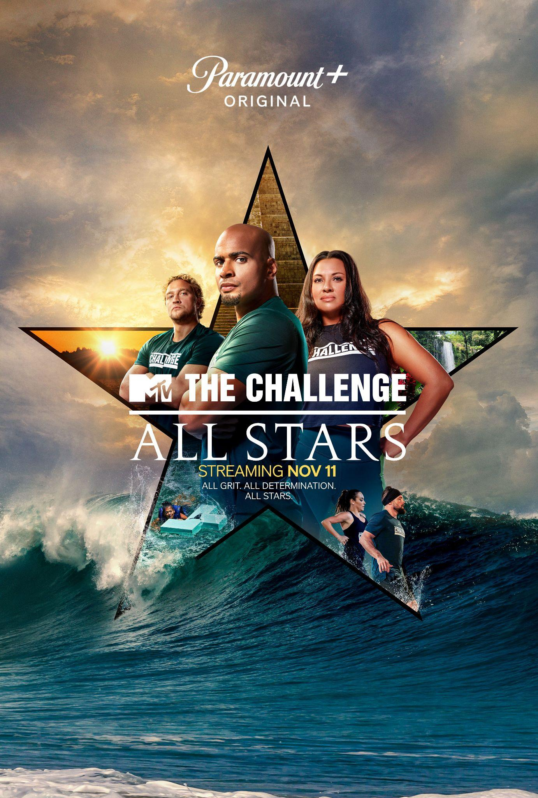

Download Key Art HERE

Download Group Photo of All Stars HERE

Download Solo Cast Photos HERE

Download First-Look Teaser HERE

Oct. 13, 2021 – Paramount+, the streaming service from ViacomCBS, and MTV Entertainment Studios today announced that, after a widely successful first outing, the powerhouse series THE CHALLENGE: ALL STARS has been greenlit for season two and will return on Thursday, Nov. 11. The 10-episode long season will drop weekly on Thursdays, exclusively on Paramount+.

Hosted by TJ Lavin, this all-new season welcomes back 24 of the fiercest reality titans from the hit franchise’s long history, including some who haven’t competed in more than 20 years. With past relationships that run deep and competitive streaks that never die, they will have to overcome the obstacles both in and out of the game to take home the win. Returning for a chance to win the ultimate competition, the players will face unprecedented, over-the-top challenges and vie for their shot at the $500,000 prize.

Meet THE CHALLENGE: ALL STARS season two contestants:

- Ayanna Mackins - 3 Challenges
- Brad Fiorenza - 10 Challenges, 1 Win (Twitter: @BradFiorenza / Instagram: @BradFiorenza)
- Casey Cooper - 4 Challenges (Instagram: @case_coop)
- Cohutta Grindstaff - 4 Challenges (Twitter: @cohuttalee / Instagram: @cohuttalee)
- Darrell Taylor - 9 Challenges, 4 Wins (Twitter: @mtvrrdarrell / Instagram: @darell_taylor_lb4lb)
- Derek Chavez - 3 Challenges (Twitter: @d_e_r_e_kc / Instagram: @d.e.r.e.k.c)
- Derrick Kosinski - 10 Challenges, 3 Wins (Twitter: @DerrickMTV / Instagram: @derrickmtv )
- Janelle Casanave - 2 Challenges, 1 Win (Instagram: @therealjanellemtv)
- Jasmine Reynaud - 5 Challenges (Instagram: @jazmtv)
- Jodi Weatherton - 2 Challenges, 3 Wins (Instagram: @jodi_mtv)
- Jonna Mannion - 5 Challenges (Twitter: @jonnamtv / Instagram: @jonnamannion )
- Katie Doyle - 9 Challenges, 1 Win (Twitter: @KatieCooley26 / Instagram: @katiecooley26)
- Kendal Darnell - 1 Challenge, 1 Win (Twitter: @KendalSheppard / Instagram: @kendalsheppard)
- Laterrian Wallace - 3 Challenges (Twitter: @latwal / Instagram: @iamlaterrian )
- Leah Gillingwater- 1 Challenge (Twitter: @EllGillingwater / Instagram: @leahgillingwater )
- Melinda Collins - 4 Challenges (Instagram: @melindastolpmtv)
- MJ Garrett - 3 Challenges, 1 Win (Instagram: @mjgarrett24)
- Nehemiah Clark - 4 Challenges, 1 Win (Twitter: @NehemiahMTV / Instagram: @nehemiahclark)
- Ryan Kehoe - 5 Challenges (Twitter: @RyanKehoe5 / Instagram: @ryankehoe5 )
- Sophia Pasquis - 2 Challenges (Instagram: @de_la_soph)
- Steve Meinke - 1 Challenge (Twitter: @reelglory)
- Teck Holmes - 1 Challenge (Twitter: @teckholmes / Instagram: @teckholmes )
- Tina Barta - 5 Challenges (Twitter: @tinabarta / Instagram: @tinabarta)
- Tyler Duckworth - 4 Challenges, 2 Wins (Twitter: @TylerDuckMTV / Instagram: @themightyduckworth )

THE CHALLENGE: ALL STARS was created for MTV Entertainment Studios by Bunim/Murray Productions. Julie Pizzi, Justin Booth and Mark Long serve as executive producers, and Diego Amson and Chris Ray as co-executive producers. Katie Gallagher and Kristen Bihr serve as supervising producers. Dan Caster and Leanne Mucci serve as executive producers with Jared March as supervising producer for MTV and Donny Herran as SVP of Production.

Multiple seasons of THE CHALLENGE are available on Paramount+, and this fall fans can also tune into THE CHALLENGE: SPIES, LIES AND ALLIES every Wednesday at 8:00 PM, ET/PT on MTV.

THE CHALLENGE: ALL STARS season two joins a growing list of unscripted originals on Paramount+, including the recently announced THE REAL WORLD HOMECOMING: LOS ANGELES premiering Wednesday, Nov. 24, as well as RUPAUL’S DRAG RACE ALL STARS, BEHIND THE MUSIC, REAL WORLD HOMECOMING: NEW YORK, and RUPAUL’S DRAG RACE ALL STARS: UNTUCKED.

For more information about Paramount+, please visit www.paramountplus.com and follow @ParamountPlus on social platforms. And follow The Challenge on Instagram, Twitter, and Facebook, subscribe to The Challenge on YouTube, and use #TheChallengeAllStars2 to join the conversation!

About Paramount+:
Paramount+, a direct-to-consumer digital subscription video on-demand and live streaming service from ViacomCBS, combines live sports, breaking news, and a mountain of entertainment. The premium streaming service features an expansive library of original series, hit shows and popular movies across every genre from world-renowned brands and production studios, including BET, CBS, Comedy Central, MTV, Nickelodeon, Paramount Pictures and the Smithsonian Channel. The service is also the streaming home to unmatched sports programming, including every CBS Sports event, from golf to football to basketball and more, plus exclusive streaming rights for major sports properties, including some of the world’s biggest and most popular soccer leagues. Paramount+ also enables subscribers to stream local CBS stations live across the U.S. in addition to the ability to stream ViacomCBS Streaming’s other live channels: CBSN for 24/7 news, CBS Sports HQ for sports news and analysis, and ET Live for entertainment coverage.

For more information about Paramount+, please visit www.paramountplus.com and follow @ParamountPlus on social platforms.

About MTV Entertainment Group:
MTV Entertainment Group reaches over 1.4 billion young people around the world across streaming, social and linear platforms in 180 countries and with more than 725 million social followers – making it one of the preeminent youth media companies in the world. Connecting with its audiences through nine iconic brands including MTV, Comedy Central, VH1, CMT, Pop, Logo, Smithsonian, Paramount Net and TV Land, MTV Entertainment Studios produces award-winning series, movies and documentary films.

About Bunim/Murray Productions:
Bunim/Murray Productions (BMP) is the leading producer of innovative entertainment content. The Emmy Award-winning company is widely credited with creating the reality television genre with its hit series The Real World, which moved to Facebook after 32 seasons on MTV. BMP continued to innovate with the first reality game show, Road Rules (MTV), in 1995; the first reality sitcom, The Simple Life (E!), in 2003; and the first reality soap opera, Starting Over, in 2003. BMP’s current programming includes Keeping up with the Kardashians, Total Bellas (E!), The Challenge (MTV), Born This Way (A&E), Kim Kardashian West: The Justice Project(Oxygen), Ball in the Family (Facebook Watch), Endless (Snapchat), Miz and Mrs. (USA Network), Family or Fiance, Iyanla Fix My Life (OWN), Crystal Maze (Nickelodeon) and Emily’s Wonder Lab (Netflix). BMP, through BMP Films, has also produced Transhood (HBO) They Call Us Monsters (PBS), Valentine Road (HBO), Pedro (MTV) and the Emmy Award-winning Autism: The Musical and Autism: The Sequel (HBO). Based in Glendale, CA, the company was founded in 1987 by Jonathan Murray and the late Mary-Ellis Bunim, who were inducted into the Television Academy’s Hall of Fame in 2012. Bunim/Murray Productions is a division of Banijay, the world’s largest international content producer and distributor.

* * *

Paramount+ Press Contacts:
Morgan Seal | Morgan.Seal@viacomcbs.com
Brian Bahr | Brian.Bahr@viacomcbs.com

MTV Entertainment Studios:
Michael Fabiani | Michael.Fabiani@viacomcbs.com
Charli Wood | Charli.Wood@viacomcbs.com

