

Jan. 26, 2026

SAM AND THE GHOSTS FACE THE OTHERS, A NEW GROUP OF SPIRITS FROM ONE GHOST’S PAST, ON “GHOSTS,” THURSDAY, FEB. 26

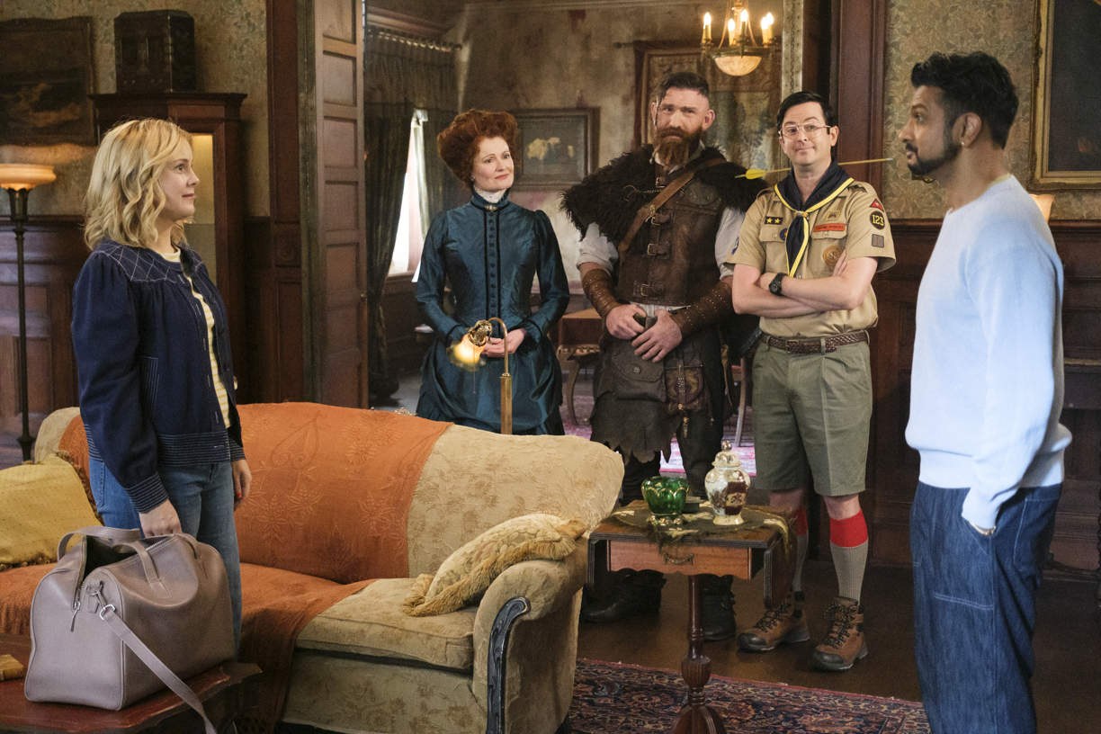

“The Others” – Sam and the ghosts face The Others, a new group of spirits from one ghost’s past. Meanwhile, Trevor tries to deal with a demanding Patience, who seeks a committed relationship in the wake of their holiday hookup, on the CBS Original series GHOSTS, Thursday, Feb. 26 (8:30-9:00 PM, ET/PT) on the CBS Television Network, and streaming on Paramount+ (live and on-demand for Paramount+ Premium plan subscribers, or on-demand for Paramount+ Essential subscribers the day after the episode airs)*.

WRITTEN BY: Skander Halim

DIRECTED BY: Todd Biermann

Click HERE for photos

Website: Paramount Press Express | CBS Entertainment | GHOSTS

*Paramount+ Premium plan subscribers will have access to stream live via the feed of their local CBS affiliate on the service, as well as on-demand. Paramount+ Essential subscribers will not have the option to stream live but will have access to on-demand the day after the show airs.

