

April 7, 2023

BEN AFFLECK, BRYAN CRANSTON, TOM CRUISE, JOSH GAD, JENNIFER GARNER, BRETT GOLDSTEIN, KATE HUDSON, ALLISON JANNEY, THE KARDASHIAN FAMILY, MILA KUNIS, SETH MEYERS, BILLY PORTER AND SHARON STONE AMONG HUGE STARS APPEARING ON THE FINAL WEEKS OF “THE LATE LATE SHOW with JAMES CORDEN” BEFORE GROUNDBREAKING SERIES WRAPS APRIL 27

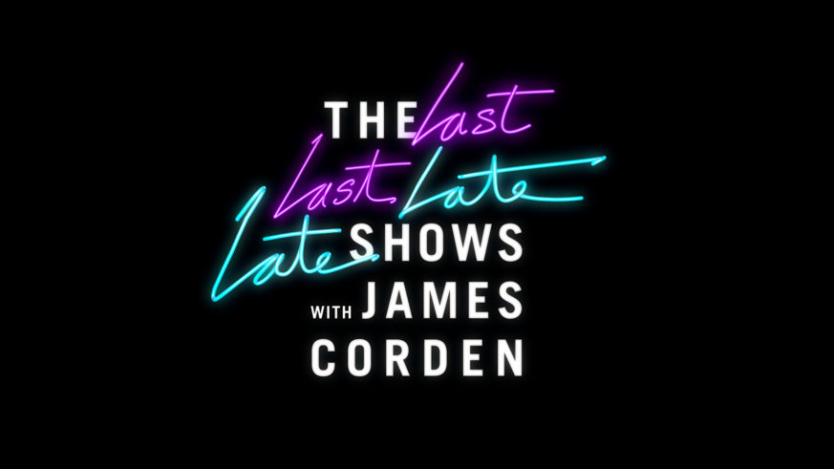

BLACKPINK Will Appear in One of Three New Editions of Carpool Karaoke

CBS Will Celebrate James Corden with a Primetime Special,
“The Last Last Late Late Show with James Corden Carpool Karaoke Special” on April 27,
Ahead of the Final “Late Late Show” Broadcast That Night

Click Here for Highlights of “The Late Late Show with James Corden”
Over the Past Eight Years

Ben Affleck, Bryan Cranston, Tom Cruise, Josh Gad, Jennifer Garner, Brett Goldstein, Kate Hudson, Allison Janney, the Kardashian family, Mila Kunis, Seth Meyers, Billy Porter and Sharon Stone are among the huge stars who will appear on THE LATE LATE SHOW with JAMES CORDEN during the last weeks of the award-winning late night series, which will air its final broadcast Thursday, April 27 (12:37-1:37 AM, ET/PT) on the CBS Television Network, and available to stream live and on demand on Paramount+*.

Global phenomenon BLACKPINK will appear in a new “Carpool Karaoke” segment during the final 12 episodes of THE LATE LATE SHOW. Also, the acclaimed late night series will feature two additional “Carpool Karaoke” segments with iconic guests, a “Take a Break” segment with the Kardashian family and a big “Crosswalk the Musical” farewell performance.

Allison Janney, who will be a guest during the last few shows, has the distinction of having the most guest appearances on THE LATE LATE SHOW, with 15 prior visits.

As previously announced, CBS will celebrate the groundbreaking impact James Corden has made on late night television with a primetime special, THE LAST LAST LATE LATE SHOW WITH JAMES CORDEN CARPOOL KARAOKE SPECIAL, airing Thursday, April 27 (10:00-11:00 PM, ET/PT) ahead of the final broadcast of THE LATE LATE SHOW WITH JAMES CORDEN that night (12:37-1:37 PM, ET/PT) on the CBS Television Network, and available to stream live and on demand on Paramount+*. Also announced earlier, global superstar Tom Cruise will join Corden for one final over-the-top sketch to air during this primetime special.

Additional guest details will be announced closer to air.

Since Corden took over as host of THE LATE LATE SHOW on March 23, 2015, the series has been nominated for 27 Emmy Awards, including Outstanding Variety Talk Series in four consecutive years. The show has earned seven Emmy Award wins for Outstanding Variety Special – Pre-Recorded for “Carpool Karaoke: When Corden Met McCartney Live from Liverpool” (2019), Outstanding Interactive Program (2016), Outstanding Variety Special for “The Late Late Show Carpool Karaoke Primetime Special” (2016 and 2017), and Outstanding Actor in a Short Form Comedy or Drama Series and Outstanding Short Form Comedy or Drama Series for “James Corden’s Next James Corden” in 2018.

THE LATE LATE SHOW with JAMES CORDEN has been a pioneer in the late night digital space, boasting five of the 10 most-watched late night clips currently available on YouTube, including “Adele Carpool Karaoke” (259 million views), “One Direction Carpool Karaoke” (194 million views) and “Justin Bieber Carpool Karaoke” (158 million views). The series has amassed over 45 million followers/subscribers across YouTube, TikTok, Instagram, Facebook and Twitter.

THE LATE LATE SHOW with JAMES CORDEN airs weeknights (12:37-1:37 AM, ET/PT) on CBS and is available to stream live and on demand on Paramount+*. The show is produced by CBS Studios and Fulwell 73 and distributed by Paramount Global Content Distribution.

*Paramount+ Premium subscribers will have access to stream live via the live feed of their local CBS affiliate on the service as well as on demand. Essential-tier subscribers will have access to on-demand the day after the episode airs.

Click HERE for photos.

Website: https://www.paramountpressexpress.com/cbs-entertainment/shows/the-late-late-show-with-james-corden/

***

Press Contacts:
Sienna Sanders |  | sienna.sanders@cbs.com
Shawna Malcom |  | shawna.malcom@cbs.com
Megan Rugani |  | megan.rugani@cbs.com

Photo Contact:
Amanda Beane |  | amanda.beane@cbs.com

