

CBS SPORTS TO PRESENT 39 CONFERENCE TOURNAMENT GAMES AND 15 AUTOMATIC BIDS TO NCAA MEN’S AND WOMEN’S BASKETBALL TOURNAMENTS
Conference tournament action tips off on CBS Sports beginning this Saturday with 39 games from nine different conferences, concluding with Selection Sunday on March 15. In total, 15 automatic bids to the NCAA Division I Men’s and Women’s Basketball Tournaments will be awarded across the CBS Television Network and Paramount+, as well as CBS Sports Network.
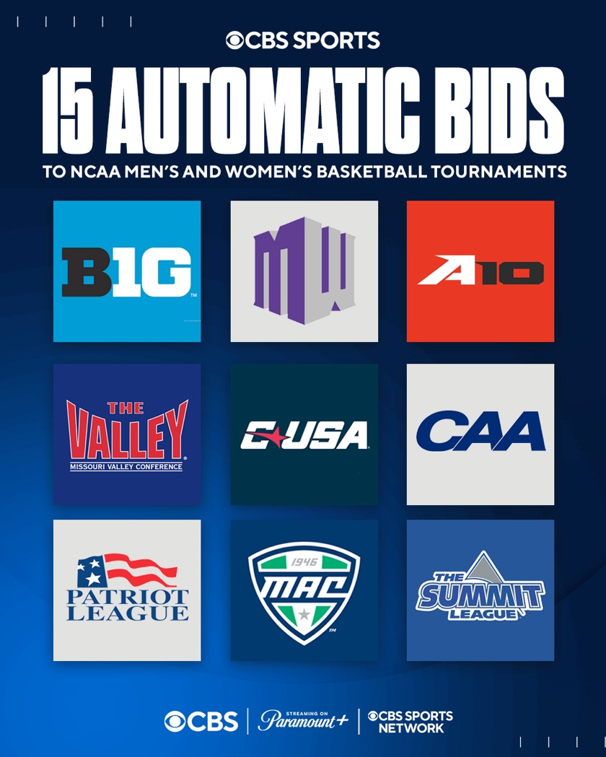
FIVE AUTOMATIC BIDS TO BE AWARDED ON CBS AND PARAMOUNT+
- Five automatic bids to the Men’s and Women’s NCAA Tournaments will be awarded on CBS and Paramount+, concluding with the Big Ten Men’s Tournament Championship for the 28th consecutive year.

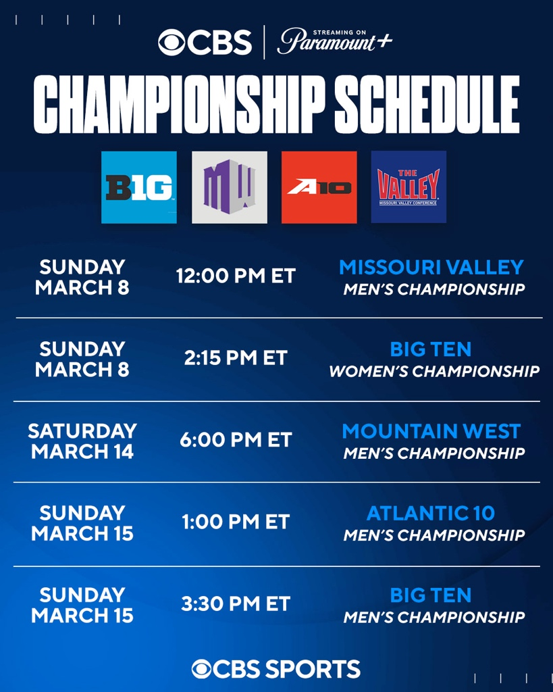
TEN CONFERENCE CHAMPIONS TO BE CROWNED ON CBS SPORTS NETWORK
- Ten automatic bids to the Men’s and Women’s NCAA Tournaments will be awarded on CBS Sports Network beginning on Sunday, March 8.
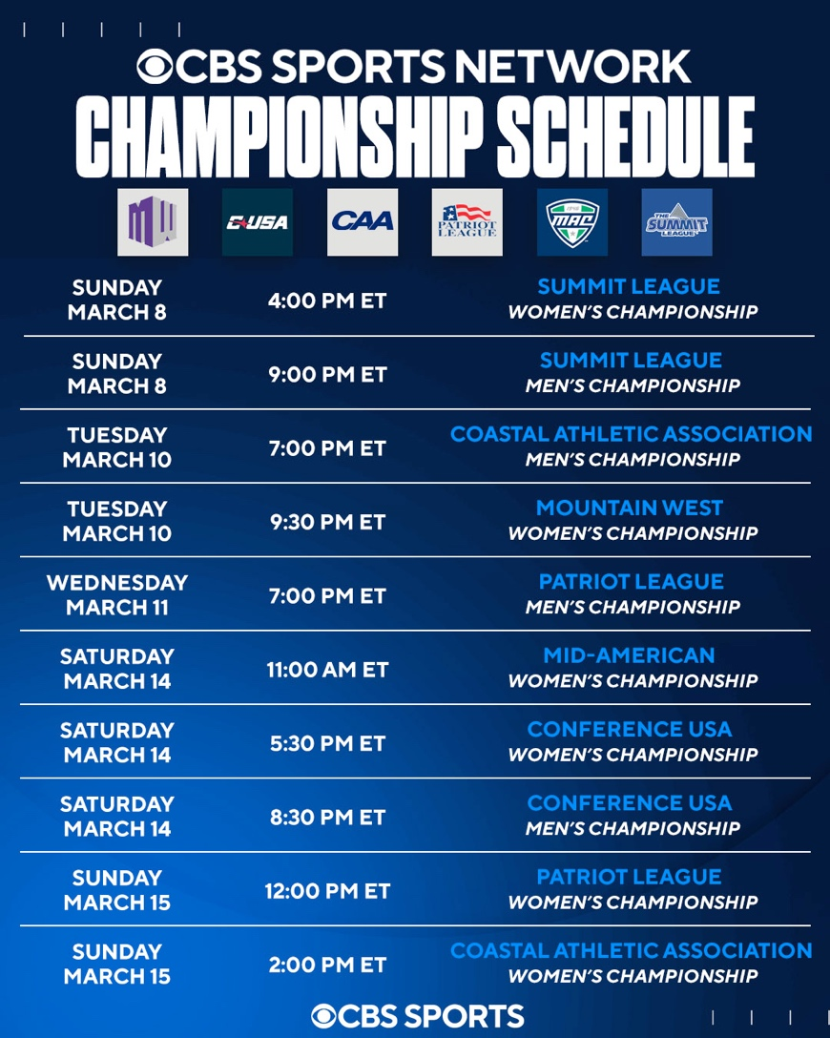
- In addition to the championship games, CBS Sports Network will feature early round action from the conference tournaments throughout “Bracket Week Presented by Kubota,” which covers 32 conference tournament games over nine days. Conference Tournament games are highlighted by Mountain West, Atlantic 10, Coastal Athletic Association, Patriot League, Conference USA, Missouri Valley, Mid-American and Summit League action.
CBS SPORTS TO PROVIDE STUDIO COVERAGE ACROSS PLATFORMS THROUGHOUT CONFERENCE TOURNAMENTS
- CBS Sports’ studio show INSIDE COLLEGE BASKETBALL will provide additional college basketball conference tournament coverage across CBS and CBS Sports Network, while CBS Sports HQ will offer fans the latest highlights, analysis and up-to-the-minute bracket breakdowns throughout each day.
- CBSSports.com and the CBS Sports App will provide comprehensive Men’s and Women’s tournament coverage, including daily bracket projections, previews and picks.
- The Eye on College Basketball podcast with Gary Parrish and Matt Norlander will offer expert insights on all the biggest storylines and moments.
- Inside College Basketball Now hosted by Jon Rothstein will feature high-profile interviews with college basketball coaches, as well as the latest news around college basketball.

CBS Sports’ full conference tournament schedules on CBS/Paramount+ and CBS Sports Network are attached.

Media Contact:
Bailey Knecht, bailey.knecht@cbs.com

