
CBS SPORTS REVEALS 2025 ‘NFL ON CBS’ ANNOUNCER LINEUP
CBS Sports has unveiled its announcer lineup for the 2025 NFL ON CBS season, beginning on Sunday, Sept. 7 on CBS and Paramount+.
For its 66th year of NFL coverage, the NFL ON CBS will broadcast more than 100 regular-season games and more Sunday games than any other network, including marquee matchups in the 4:25 PM, ET national game window, the most-watched window in all of television.
The full game announcer lineup is below.
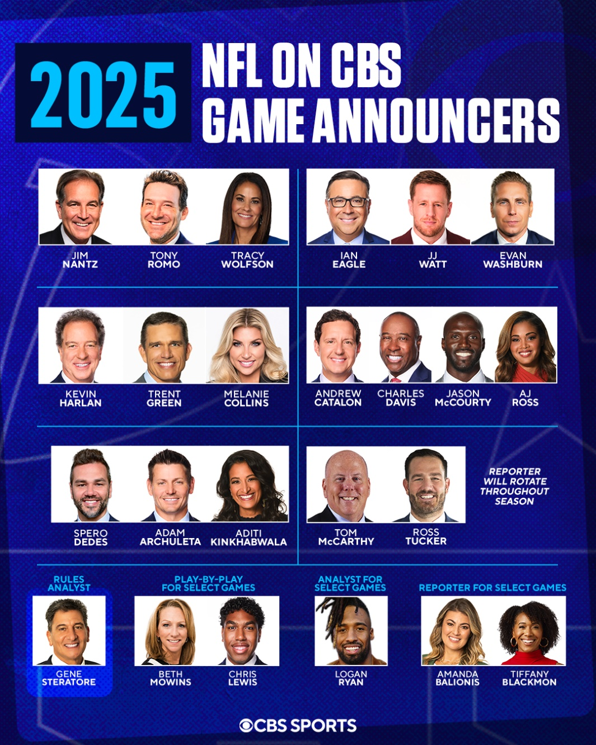

THE NFL TODAY will feature host James Brown alongside analysts Bill Cowher, Nate Burleson and Matt Ryan. This season, the show will hit the road on select Sundays for some of CBS Sports' most-anticipated games, starting in Week 1 from Lambeau Field when the Packers host the Lions.


