

TWIN SISTERS SAY THEY WERE ATTACKED BY A BLACK MAN – HE SPENT 44 YEARS IN PRISON – ARE THE SISTERS TELLING THE TRUTH OR HIDING A FAMILY SECRET?

“48 Hours” Investigates in “Please Don’t Tell”

Saturday, May 21

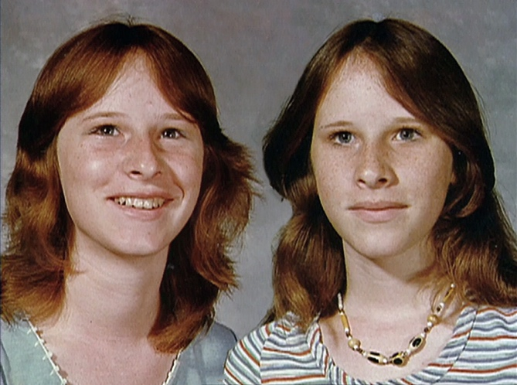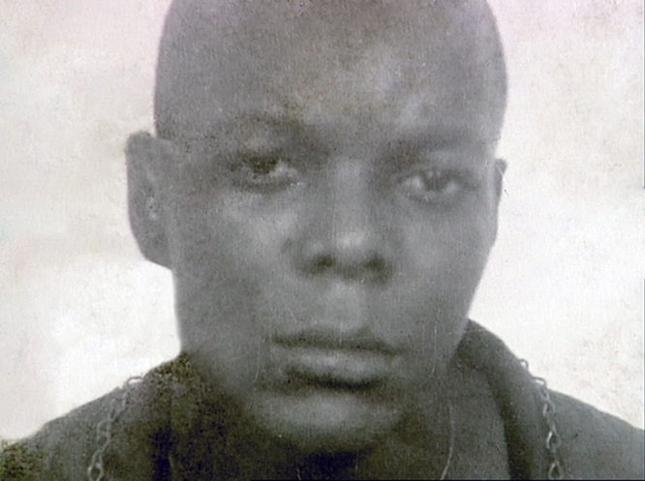
(L-R) Karen and Sharon Sanders; Vincent Simmons in 1977

Watch a Preview

Vincent Simmons was released from a Louisiana prison earlier this year after serving 44 years for attempted aggravated rape of twin sisters. He says he didn’t do it – but the twin sisters say he’s guilty. Are the sisters telling the truth or hiding something? 48 HOURS and contributor David Begnaud investigate the case against Simmons and hear for the first time from a woman who says she knows the truth, in “Please Don’t Tell,” to be broadcast Saturday, May 21 (10:00-11:00 PM, ET/PT) on the CBS Television Network and streaming on Paramount+.

In 1977, Simmons was convicted of two counts of attempted aggravated rape of identical 14-year-old twins, Karen and Sharon Sanders, and sentenced to 100 years in prison. The Sanders sisters say their cousin, Keith Laborde, was driving them when he gave Simmons a ride. They say Simmons forced Laborde into the trunk then raped them. The Sanders sisters say Simmons warned them not to tell anyone about what had happened. They say they initially intended to keep it a secret, but Karen Sanders decided to confide in a family member.

“And I said, ‘But please, please don’t tell anyone. Please don’t tell anyone,’” Karen Sanders says.

It didn’t stay secret for long. The police soon found out and Simmons was arrested, convicted and sentenced to prison. This year, Simmons was released after a judge vacated his conviction after finding he didn’t get a fair trial. The court did not rule on his innocence or guilt, and the district attorney declined to retry him

It’s a case that raises questions about potential flaws in the legal system and alleged racism, and whether it was just for this man to spend most of his life behind bars.

“When I saw him in that lineup, I didn’t have to think twice,” says Karen Sanders. “When I looked at him, I knew him.”

The sisters don’t doubt that they picked the right man out of the lineup.

“I didn’t rape Karen and Sharon Sanders,” Simmons says. “I don’t know these people.”

Simmons’ attorney, Justin Bonus, believes the twins are lying to protect Keith Laborde. Laborde’s cousin, Dana Brouillette, told a private investigator and swore in an affidavit in 2020 that Laborde admitted to her that Simmons was never with them that night. Instead, she said in the affidavit that Laborde told her “he had consensual sex with one of the girls and locked the other in the trunk.” Laborde denied ever having sex with them.

What exactly happened? Was Simmons railroaded by a racist system, as his lawyer maintains? Or is he guilty, as the sisters say?

Begnaud and 48 HOURS report on the case through interviews with Simmons, the Sanders sisters, Laborde, attorneys and prosecutors. The judge in the case also gave a revealing interview to Begnaud.

48 HOURS: “Please Don’t Tell” is produced by Stephanie Slifer, Sarah Prior and Murray Weiss. Stephen A. McCain is the development producer. CBS News producers are T. Sean Herbert, Chris Weicher and Maryhelen Campa. Doreen Schechter is the producer-editor. Richard Barber and Marlon Disla are the editors. Patti Aronofsky is the senior producer. Nancy Kramer is the executive story editor. Judy Tygard is the executive producer.

48 HOURS is broadcast Saturdays at 10:00 PM, ET/PT on CBS, and streams anytime on Paramount+. There’s also a new way to watch 48 HOURS. You’ll find us on the CBS News Streaming Network Wednesdays at 8:00 PM, ET. Download the CBS News app on your phone or connected TV. Follow 48 HOURS on Twitter, Facebook and Instagram. Listen to podcasts at CBSAudio.

***
Press Contact:
Richard Huff |  | Huffr@cbsnews.com

