

Jan. 24, 2020

AN INDIANA WOMAN REVEALS HER SEARCH FOR HER FAMILY’S KILLER, AND HER WILL TO SURVIVE, IN AN EMOTIONAL “48 HOURS: LIVE TO TELL: MURDER ON PROM NIGHT”

Saturday, Jan. 25

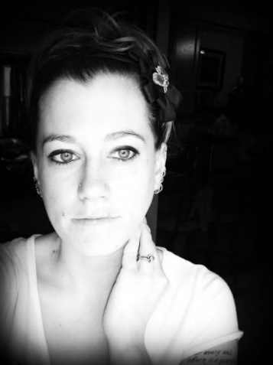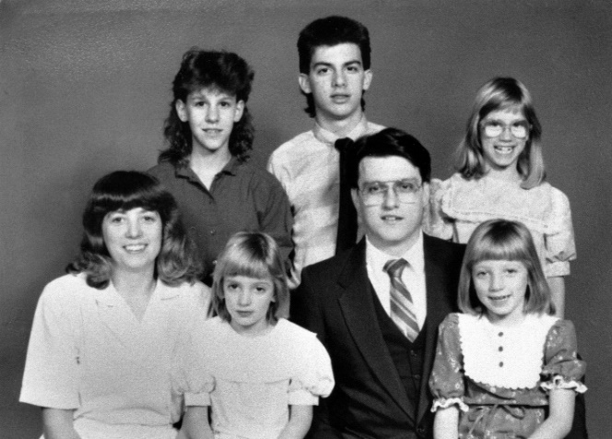

Click Here for a Preview

Jessi Toronjo was just 9 years old when she returned from a sleepover at a friend’s house to find out her mother, stepfather and two sisters were murdered. More than three decades later, Toronjo shares her emotional story of the search for her family’s killer and putting her life back together, in 48 HOURS: “Live to Tell: Murder on Prom Night” to be broadcast Saturday, Jan. 25 (10:00 PM, ET/PT) on the CBS Television Network.

“I had just lost everything,” Toronjo says. “I pretty much became an orphan in a day.”

Anchored by Jim Axelrod, “Live to Tell: Murder on Prom Night” is the heartbreaking and inspiring story of a woman’s search for answers after her family was murdered and how she has tried to cope with her terrible past. Told through Toronjo’s point of view, she tells viewers how her family was torn apart by murder then rocked again 17 years later when her stepbrother was convicted for the crime. Authorities believed Jeff Pelley killed his family over an argument over the prom. The case continues to wind its way through the courts to this day and make headlines.

On April 30, 1989, police responded to a grizzly crime scene in Lakeville, Ind.

“No one should have seen what we saw that morning,” says former Indiana State Police Detective Mark Senter. Upstairs in the hallway, Reverend Bob Pelley was found shot to death. Downstairs in the basement, police found the bodies of Pelley’s wife, Dawn Pelley, and her daughters Janel, 8, and Jolene, 6. They had all been shot at close range with a shotgun.

When the murders occurred, Jessi was known as Jessica Pelley. Today, she’s changed her name to Jessi and dyed her hair bright pink, all a mechanism of coping with the tragedy, she says.

“I decided to change my hair,” she says. “I also changed my name to Jessi. Jessica, I no longer wanted that name because she was a very sad, lonely, angry little girl.”

Jeff Pelley, then 17, was brought in for questioning after the murders. He told police he had no idea who would want to kill his family. Investigators later learned Jeff’s father had grounded him in the weeks leading up to the murders, meaning he couldn’t go to the prom without his father driving him and he couldn’t attend all the prom-related activities. Police believe he killed the family so he could go to the prom on his own terms.

While investigators had a motive, the case against Jeff Pelley was thin, says John Botich, a retired St. Joseph’s County detective who also worked the case.

“We didn’t have forensic evidence. We didn’t find a murder weapon. No eyewitnesses,” Botich says. “Very tough case to prove, very tough case to prosecute.”

It took 13 years before Pelley was arrested.

“When I heard Jeff was arrested,” Toronjo says, “I was scared he was going to get out, come after me. When he’s angry, he’s not a nice person.”

Jeff Pelley was convicted of murder in 2006. His attorneys have always maintained that he is innocent, and today a new legal team is making a new push for his release.

“It is really a form of slow torture,” Toronjo says. “But I fully believe he is not getting out.”

48 HOURS: “Live to Tell: Murder on Prom Night” takes viewers inside Toronjo’s story from that terrifying morning and how her life has unfolded since that fateful day.

“Live to Tell” is a short-run series from the producers of 48 HOURS delivering first-person accounts of extraordinary people who refuse to give up when facing possible death and hardship. 48 HOURS: “Live to Tell: Murder on Prom Night” is produced by Chris O’Connell and Stephanie Slifer. Ryan Smith is the development producer. Marlon Disla and Doreen Schechter are the producer-editors. Lourdes Aguiar is the senior producer. Nancy Kramer is the executive story editor. Judy Tygard is the series creator and executive producer.

Follow 48 HOURS on Twitter, Facebook and Instagram. Listen to podcasts at CBSAudio.

* * *
Press Contact:
Richard Huff | 212-975-3328 | huffr@cbsnews.com

