

Oct. 24, 2019

“48 HOURS” EXPLORES THE RIVETING REAL-LIFE MURDER MYSTERY AROUND THE DEATH OF A NEW YORK CITY BUSINESSMAN AND THE 23-YEAR SEARCH FOR ANSWERS, IN “WHO WANTED HOWARD PILMAR DEAD?”

Pilmar’s Father and Stepmother Speak Out About the Case in Their First Network TV Interviews

Saturday, Oct. 26

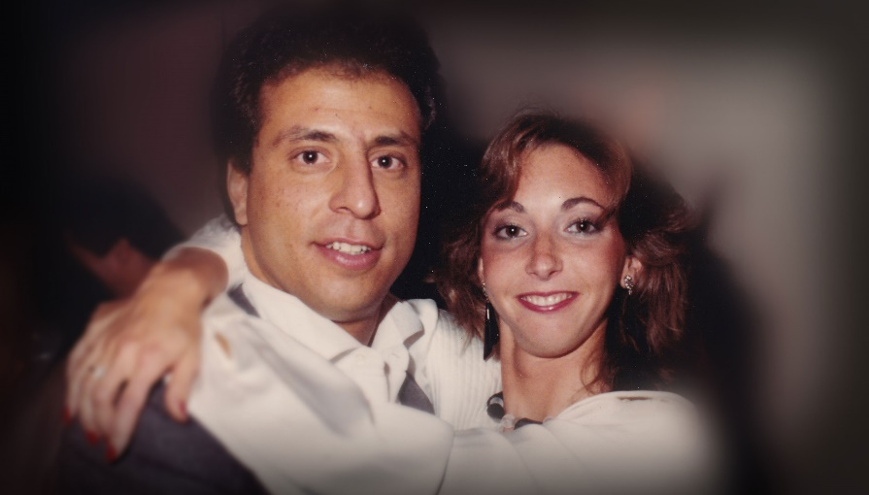

Click Here for a Preview

New York City businessman Howard Pilmar was murdered in the headquarters of his successful office supply store and coffee shop in 1996. Police suspected his wife killed him with help from her brother. Why would she want him dead? It would take more than two decades to get answers.

Correspondent Richard Schlesinger and 48 HOURS go inside the riveting real-life murder mystery behind the death of Pilmar and the search for answers in “Who Wanted Howard Pilmar Dead?” to be broadcast Saturday, Oct. 26 (10:00 PM, ET/PT) on the CBS Television Network. The broadcast features the first network television interviews with Pilmar’s father and stepmother, his family and the supervisor of the investigation.

Pilmar’s body was found in a pool of blood. He had been stabbed repeatedly, and investigators say he was even stabbed after he was dead.

“This is: I want to make sure you’re dead, absolutely dead, completely and utterly dead,” says former New York Police Department commander Roger Parrino.

It’s a twisted case, sparked by greed, hate and debt, and relationships that, to the outside, were portrayed as wonderful, but behind closed doors were a different story.

Why would someone want him dead so badly? NYPD detectives couldn’t find someone with the kind of hatred that would lead to murder – until they discovered surprises about Pilmar’s wife, Roslyn, and her brother, Evan Wald. Roslyn inherited more than a $1 million in life insurance, plus the family’s real estate holdings and the company that Howard Pilmar’s father, Frank, built. For more than two decades, prosecutors didn’t believe there was enough evidence to charge anyone with the murder.

“He was stabbed over 40 times,” says Pilmar’s stepmother, Carol Pilmar. “It had to be somebody he knew, that hated him so much.”

“He was slaughtered,” says Frank Pilmar.

The murder shook Howard Pilmar’s family and friends. There were no witnesses, and police never found a weapon, nor had they identified any suspects other than Roslyn Pilmar and Evan Wald.

“I have my life before Howard was killed and after Howard was killed,” says Pilmar’s stepsister, Heather. “They didn’t really understand the ramifications of it. How it would change my father. How it would change the dynamic of my family.”

The case then went cold, and Roslyn Pilmar and Evan Wald went on with their lives. But then NYPD cold case investigators and Manhattan prosecutors spent four years reviewing the evidence and finding new witnesses. Finally, there were some new clues.

Schlesinger and 48 HOURS report the story through interviews with Howard Pilmar’s family and friends, investigators who handled the case at the time, and more.

48 HOURS: “Who Wanted Howard Pilmar Dead?” is produced by Lisa Freed and Murray Weiss. Doreen Schechter and Phil Tangel are the editors. Gabriella Demirdjian is the field producer. Marc Goldbaum is development producer. Patti Aronofsky is the senior producer. Anthony Batson is the senior broadcast producer. Nancy Kramer is the executive story editor. Judy Tygard is the executive producer.

Follow 48 HOURS on Twitter, Facebook and Instagram. Listen to podcasts at CBSAudio.

* * *
Press Contact:
Richard Huff | 212-975-3328 | huffr@cbsnews.com

