

Sept. 16, 2019

“48 HOURS” CORRESPONDENT ERIN MORIARTY HOSTS AN ORIGINAL PODCAST “MY LIFE OF CRIME” AVAILABLE NOW ON APPLE PODCASTS AND WHEREVER YOU GET YOUR PODCASTS

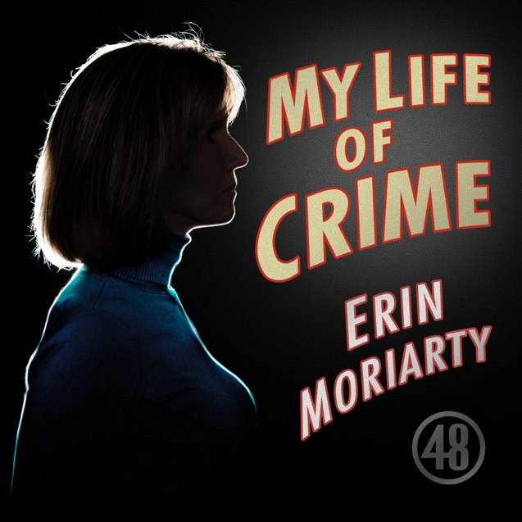

Click Here to Listen to “My Life of Crime”

Award-winning correspondent Erin Moriarty brings you “My Life of Crime,” a new podcast from the producers of 48 HOURS, America’s #1 Saturday night true-crime destination. Moriarty’s six-episode series is available now on Apple Podcasts and wherever you get your podcasts.

Moriarty delivers an immersive, intimate and sometimes irreverent take on true-crime cases. Some are infamous, some are little known, but all include Moriarty’s signature reporting. In true Moriarty style, Erin brings listeners along on her investigation, going to the scene of a crime, behind prison walls, and deep into her own personal horror story. (Don’t worry, it ends well.) And the podcast shows the lengths Moriarty will go to get a story.

“Erin, there is no excuse for giving a serial killer your home address,” says Richard Schlesinger, Moriarty’s partner-in-crime for one of the podcasts.

The six-part series is varied and diverse. In one episode, Moriarty spends the night where Lizzie Borden is famously accused of killing two people with an ax. Everyone knows the nursery rhyme “Lizzie Borden took an ax and gave her mother 40 whacks….” However, Moriarty’s re-examination of the case has a surprising conclusion.

Was there foul play, or was it an accident the night Natalie Wood died? When veteran investigators decided to break their silence about the case, it was to Moriarty and 48 HOURS. Moriarty will continue her dedicated reporting on the death investigation, joined in this episode by Lana Wood, Wood’s sister. Lana has spent decades searching for answers about what happened that November night in 1981, when America lost one of its most beloved and glamorous movie stars.

Bedford Hills Correctional Facility is home to some of New York’s most violent criminals. Moriarty spent time getting to know them in a most unusual setting: music class. They speak openly about the crimes that brought them behind prison walls, and the music that helps them escape – at least temporarily. And Moriarty also has her own, personal true-crime journey to share when she introduces listeners to a young, aspiring Hollywood horror writer and producer, who just happens to be someone Erin knows and loves.

Moriarty has been a correspondent for 48 HOURS since 1990. Her reporting appears across all CBS News platforms and programs. Her work has been honored with virtually every major broadcast journalism award, including nine Emmy Awards. In 2019 she received the Lifetime Achievement Award from the Alliance for Women in Media Foundation. “My Life of Crime” is created by the team at 48 HOURS. Judy Tygard is the executive producer. Nancy Kramer is the executive story editor. Michael Vele is the series producer/editor. Luis Giraldo, Marc Goldbaum, Tamara Weitzman, Liza Finley, Ryan Smith and Jaime Hellman are the producers. Morgan Canty and Emma Steele are the associate producers.

The next installment of “My Life of Crime,” along with the premiere episode, will be available Tuesday, Sept. 17.

Follow 48 HOURS on Twitter, Facebook and Instagram. Follow Erin Moriarty on Twitter at @EFMoriarty. Subscribe to “My Life of Crime” on Apple Podcasts and wherever you get your podcasts.

* * *

Press Contact:
Richard Huff | 212-975-3328 | huffr@cbsnews.com

