

August 1, 2019

A “48 HOURS” INVESTIGATION INTO THE MYSTERIOUS DEATH OF A YOUNG SOUTH CAROLINA MOM AND HER INFANT DAUGHTER HELPS REOPEN THE CASE – WAS IT SUICIDE… AN ACCIDENT… OR MURDER?

“48 Hours: Fatal Crossing”

Saturday, August 3, 10:00 PM

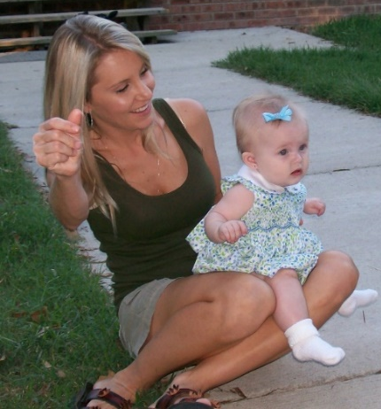

Watch a Preview Here: https://cbsn.ws/2H7yD4r

A 48 HOURS investigation has helped lead police to reopen the case of a young mother and her daughter found dead along railroad tracks in South Carolina. Peter Van Sant and 48 HOURS investigate the 2008 death of Kadie Major and her 10-month-old daughter River Lynn and the search for what happened, in an encore of “Fatal Crossing,” to be broadcast Saturday, August 3 (10:00 PM) on the CBS Television Network. It is a case about unusual deaths, a reportedly unusual reaction by a husband who lost a wife, a daughter and an unborn child, and a mother unwilling to give up the search for answers. It is also a case that got new life when 48 HOURS producers began asking questions of a new sheriff who was willing to have his team take a second look. Was it a murder-suicide as investigators initially reported? Or were Kadie Major and her baby daughter murdered?

Follow 48 HOURS on Twitter, Facebook and Instagram. Listen to podcasts at CBSAudio.com.

* * *

Press Contact:
Richard Huff | 212-975-3328 | huffr@cbsnews.com

