
April 24, 2019

THE SUICIDE OF A 16-YEAR-OLD UTAH TEENAGER WAS A TRAGEDY,
BUT WAS HOW IT HAPPENED A CRIME?

“48 Hours” Investigates in “A Death in Payson Canyon”

Saturday, April 27, 10:00 PM

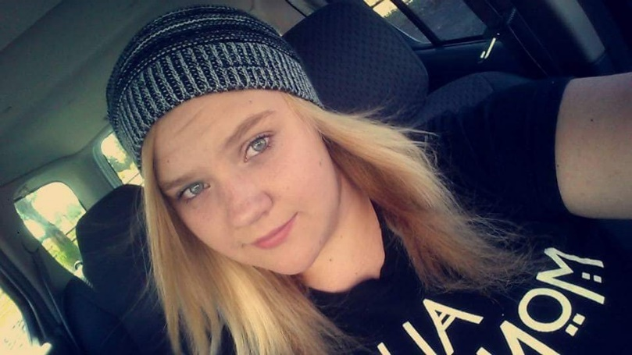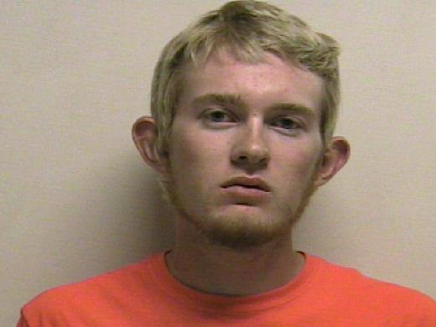

Click Here for a Preview

Without question, the death by suicide of 16-year-old Utah teen Jchandra Brown on May 5, 2017 was a tragedy. But was how it happened a crime? David Begnaud and 48 HOURS investigate the death of Brown and the search to find out what really happened to her in “A Death in Payson Canyon” to be broadcast Saturday, April 27 (10:00 PM, ET/PT) on the CBS Television Network.

“A Death in Payson Canyon” is the stunning and heartbreaking story of a family, a community and authorities struggling to make sense of a young girl’s death by suicide, only to discover that her friend, who had many opportunities to stop her, helped her complete the act instead. The broadcast also explores the broader issue of teen depression.

“Jchandra was my world. She was my life,” says the teen’s mother, Susan Bryan. “When Jchandra died, my heart shattered.”

Brown’s body was found by a turkey hunter in the woods in Payson Canyon, Utah. To police, the scene initially looked like a clear-cut case of suicide. It was anything but that. There were clues that something wasn’t right. Nearby, police found a note.

“It says, ‘My name’s Jchandra Brown and I hated my life,’” says Utah County Sheriff’s Detective Quinten Fackrell. “‘Watch the video. It’s on my phone.’”

Brown’s phone, also found nearby, contained a 10-minute video of her suicide that was shot by someone she knew. They found two grocery bags as well, one of which had a receipt for rope, purchased with a debit card belonging to Tyerell Przybycien.

As police continued searching the area where Brown was found, Przybycien walked up.

“He introduces himself to me as Tyerell Przybycien,” recalls Sgt. Josh Chappell. “And he goes, ‘I think you want to talk to me. I need to tell you the whole story.’”

Przybycien told police he was just helping Jchandra do what she wanted to do, but detectives later discovered new evidence that showed this may have been Tyerell’s plan all along – such as a text he sent to a friend stating, “It’s like getting away with murder.” And with that, Utah County prosecutors decided to charge Przybycien with first-degree murder.

“In his mind, I don’t think that he was committing murder. He was helping her do what she wanted to do,” says Neil Skousen, Przybycien’s attorney.

“This goes beyond making bad mistakes,” says Prosecutor Chad Grunander. “This was criminal behavior. There’s no doubt in my mind that Jchandra does not die on May 5, 2017, if she had never met Tyerell.”

David Begnaud and 48 HOURS explore the events that brought Jchandra Brown and Tyerell Przybycien together in the remote woods in Payson Canyon that evening, leaving one dead and the other on trial for murder.

48 HOURS: “A Death in Payson Canyon” is produced by Josh Gelman. Greg Fisher is the development producer. Michael Baluzy, Karen Brenner, Diana Modica and Gary Winter are the editors. Richard Fetzer is the associate producer. Peter Schweitzer is the senior producer. Nancy Kramer is the executive story editor. Judy Tygard is the executive producer.

Follow 48 HOURS on Twitter, Facebook and Instagram. Listen to podcasts at CBSAudio.

* * *

Press Contact:
Richard Huff | 212-975-3328 | huffr@cbsnews.com

