

CBS NEWS CALIFORNIA INVESTIGATES DEBUTS NEW YEAR’S DAY SPECIAL “CALIFORNIA’S FENTANYL FIGHT: POLITICIANS V. PARENTS”

The Groundbreaking Investigation Airs New Year’s Day on CBS California Owned Stations in Los Angeles (KCAL), San Francisco/Bay Area (KPIX) and Sacramento (KOVR) and is Available to Stream Live

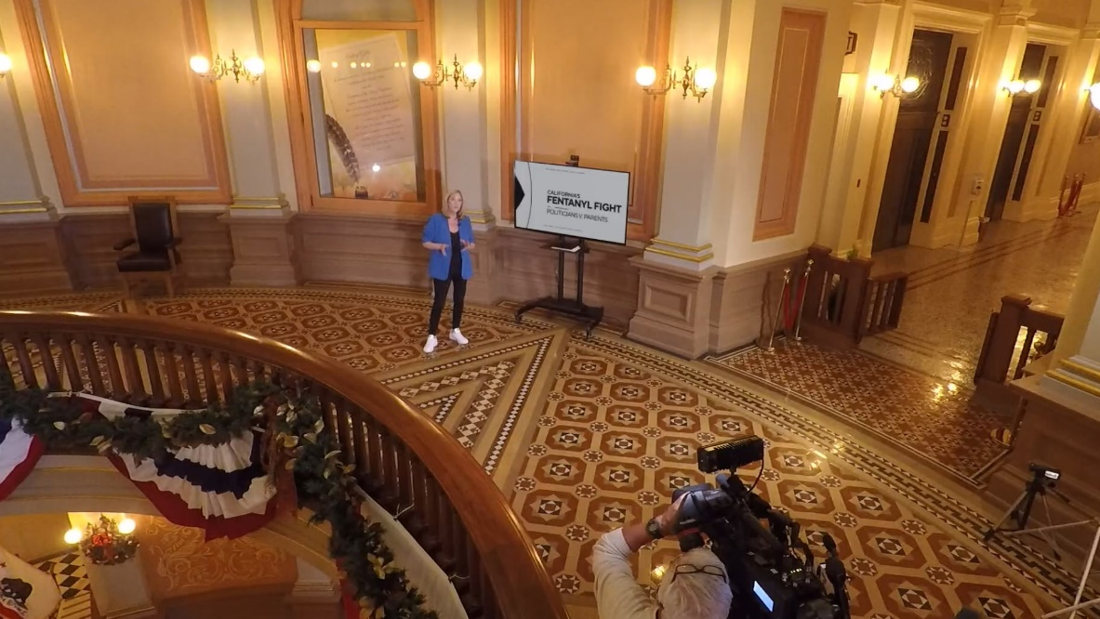
California Correspondent Julie Watts at the California State Capitol

SACRAMENTO – Dec. 31, 2024 – CBS News California Investigates continues its mission to bring transparency to California’s capitol and make accountability journalism resonate with broader audiences. “California’s Fentanyl Fight: Politicians V. Parents” debuts Jan. 1, 2025, on CBS Los Angeles (KCAL-TV), CBS Sacramento (KOVR-TV) and CBS Bay Area (KPIX-TV) linear and streaming channels. Since CBS News California Investigates’ launch in March 2024, the initiative has delivered hard-hitting investigative stories that expose statewide systemic issues while empowering viewers with the truth.

The upcoming 30-minute special, “California’s Fentanyl Fight: Politicians V. Parents,” combines gripping investigative reporting, led by regional California correspondent Julie Watts, with groundbreaking data journalism utilizing a new AI tool through CalMatters’ Digital Democracy database, designed to hold lawmakers accountable. The special uncovers how California lawmakers avoid accountability by killing controversial legislation without voting on the record.

The year-long investigation provides a rare and unprecedented view of California’s one-party supermajority through the eyes of grieving parents who lost their children to fentanyl, only to discover California lawmakers killed popular fentanyl bills by not voting. It captures one of the hardest-fought political battles of the year: parents advocating for stronger criminal penalties against fentanyl-related crimes versus powerful politicians opposed to these measures.

Programming schedule for “California’s Fentanyl Fight: Politicians V. Parents”:

- CBS Los Angeles (KCAL): Wednesday, Jan. 1, 2025, at 12:00 PM
- CBS Sacramento (KOVR): Wednesday, Jan. 1, 2025, at 4:00 PM
- CBS Bay Area (KPIX): Wednesday, Jan. 1, 2025, at 5:30 PM

Editor’s Note: Image Courtesy of CBS Stations

For more information, contact:
Elita.adjei@paramount.com

About CBS News California Investigates
Launched in March 2024, CBS News California Investigates is dedicated to bringing transparency to California’s capitol and producing accountability journalism that informs and empowers audiences across the state.

