
INSIDE EDITION EXCLUSIVE:
MAN TARGETED IN ALLEGED MURDER-FOR-HIRE PLOT BY HIS FORMER NYPD EX-WIFE SPEAKS OUT

“I thought I was marrying someone who swore to protect and serve, a cop. Instead, I got a crazed lunatic.”
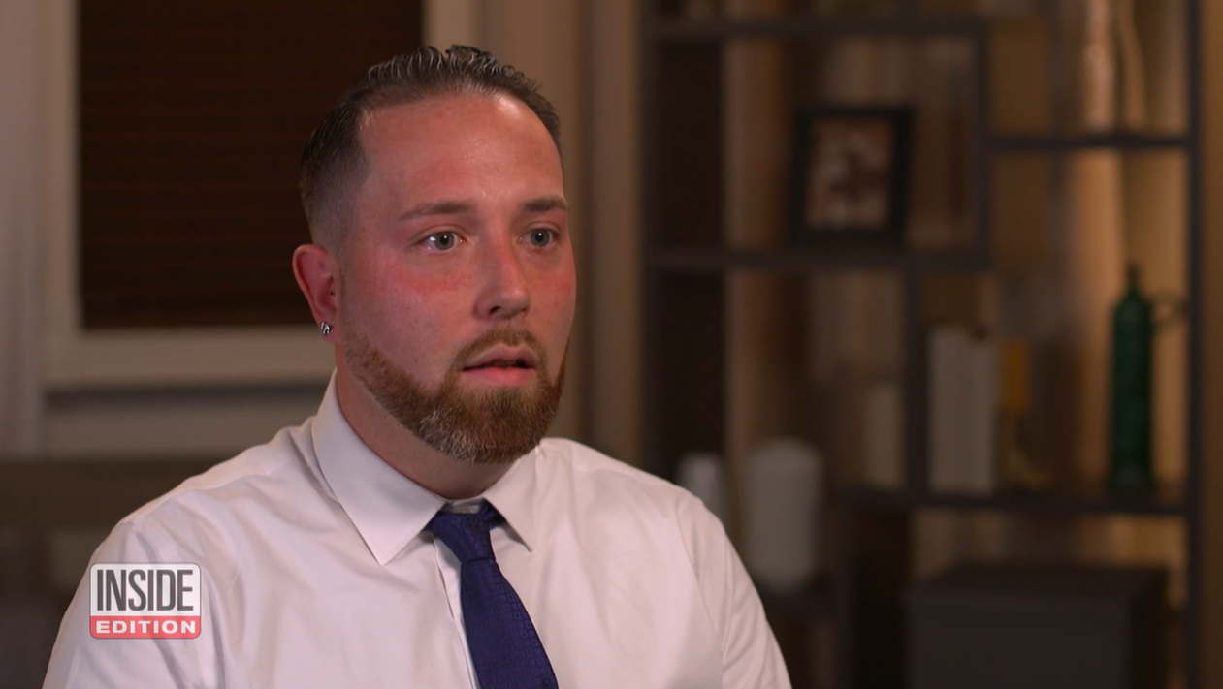
AIRING ON WEDNESDAY, FEBRUARY 2ND
Check local listings at www.insideedition.com

VIDEO LINK (MUST CREDIT INSIDE EDITION AND LINK BACK):
https://ietv.co/3HE4ZQN

New York, NY – February 2, 2022 – In an exclusive airing on Wednesday, INSIDE EDITION speaks with Isaiah Carvalho, the man whose estranged ex-wife, Valerie Cincinelli, was charged with plotting to kill him in a murder-for-hire.

Valerie Cincinelli was a New York City police officer. She and Carvalho had been married for five years and had one son together.

“We were fighting all the time,” Carvalho tells INSIDE EDITION, “I thought I was marrying someone who swore to protect and serve, a cop. Instead, I got a crazed lunatic.”

In 2019, the couple was going through a divorce and Cincinelli allegedly schemed to murder her husband. Cincinelli was charged with putting her boyfriend, John DiRubba in charge of hiring a hitman for $7,000 and converting it into gold to make it untraceable.

When asked by INSIDE EDITION if Cincinelli thought she would get away with it, Carvalho says, “I really believe she did. She went through with it. Took gold coins out. She had every intention of going through with it.”

Cincinelli’s alleged plan was foiled when cops say she wanted to add one more victim to the list. She was said to be jealous of DiRubba’s 13-year-old daughter because he often bought her expensive gifts. This reportedly led DiRubba to go straight to the FBI.

Carvalho says the two men worked with the FBI to stage a realistic crime scene.

“The FBI told me to sit in the car. They took glass they put it all on the floor and told me to hunch over into the passenger seat,” he tells INSIDE EDITION.

The staged photo was shown to Cincinelli as proof of death and believing her husband had been killed, her boyfriend secretly recorded what happened next as prosecutors say she tried to cover her tracks. Instead, the FBI moved in and Cincinelli was arrested.

When asked by INSIDE EDITION if Carvalho worries that when she gets out, she’ll get someone to actually do the job, Carvalho says, “I look over my shoulder constantly. Not a day goes by I’m not afraid for my life.”

Cincinelli pled guilty to obstruction of justice and was sentence to 48 months in prison. The murder-for-hire charges against her were dropped. DiRubba was not charged.

For INSIDE EDITION’s full report, tune in on Wednesday, February 2nd. Check local listings for times and stations in your area.

VIDEO EMBED CODE: <div style="position: relative; max-width: 640px;"><div style="padding-top: 56.25%;"><div style="position: relative; max-width: 640px;"><div style="padding-top: 56.25%;"><iframe src="https://embed.insideedition.com/video-embed/embed_4_player/802f6d8c-c75c-4967-9636-acabe5be3c62" allowfullscreen frameborder="0"></iframe></div></div></div></div>

INSIDE EDITION is produced daily by Inside Edition Inc. and distributed by CBS Media Ventures.

Follow INSIDE EDITION on Facebook, Twitter, Instagram, and TikTok.

###
Press Contacts:

Bettina Cataldi
Publicist
INSIDE EDITION
516-780-2785 (c)
Bettina.Cataldi@viacomcbs.com

Samantha Gaudio
Publicity Assistant
INSIDE EDITION
Samantha.Gaudio@viacomcbs.com

