
Feb. 26, 2019

“48 HOURS: PORTRAIT OF A KILLER” IS SATURDAY’S #1 PRIMETIME PROGRAM WITH VIEWERS AND POSTS WEEK-TO-WEEK INCREASES

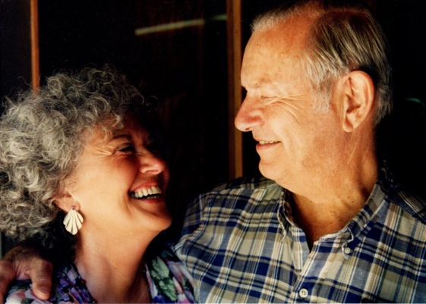
(L-R) Claudia Maupin, Chip Northup and Daniel Marsh

Click Here to Watch This Broadcast

48 HOURS: “Portrait of a Killer” was Saturday’s #1 primetime program with viewers, according to Nielsen live plus same day ratings for Feb. 23.

At 10:00 PM, the broadcast delivered 4.30 million viewers and a 0.9/03 with adults 25-54, the demographic that matters most to those who advertise in news. 48 HOURS added +1.54 million viewers (from 2.76m, +56%) and was up +80% in adults 25-54 (from 0.5/02) compared to the previous week.

“Portrait of a Killer” featured Erin Moriarty and 48 HOURS’ investigation into the brutal double homicide of an elderly California couple and the controversial law that might free their convicted killer, Daniel Marsh, when he turns 25.

Six years ago, someone savagely stabbed to death Chip Northup, 87, and Claudia Maupin, 76, as they slept inside their Davis, Calif., home. Two months after the April 14, 2013 murders, police got an unexpected tip from a teenager saying his best friend, then-15-year-old Daniel Marsh, had bragged about the murders.

Marsh was tried as an adult, convicted and sentenced to 52 years to life. Four years after Marsh’s conviction, a new California law has thrown his sentence into jeopardy. Now, his lawyers are arguing that Marsh should be re-sentenced as a juvenile. If successful, Marsh, now 21, might be released on his 25th birthday.

48 HOURS: “Portrait of a Killer” is produced by Judy Rybak and Stephanie Slifer. Greg Fisher is the development producer. George Baluzy and Jud Johnston are the editors. Patti Aronofsky is the senior producer. Nancy Kramer is the executive story editor. Judy Tygard is the executive producer.

Follow 48 HOURS on Twitter, Facebook and Instagram. Listen to podcasts at Radio.com.

* * *

Press Contact:
Richard Huff | 212-975-3328 | huffr@cbsnews.com

