

Oct. 28, 2025

MARK HARMON TO MAKE SPECIAL GUEST APPEARANCE AS GIBBS ON “NCIS: ORIGINS” DURING “NCIS” CROSSOVER EVENT TUESDAY, NOV. 11

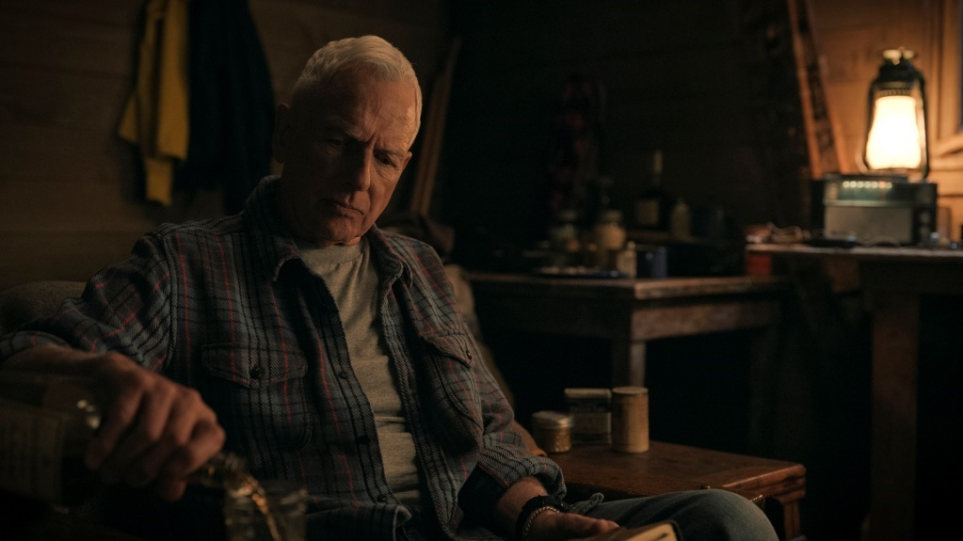
Photo credit: CBS

Mark Harmon will make a special guest appearance as Leroy Jethro Gibbs, the iconic TV character he played for 18 seasons on NCIS, on prequel series NCIS: ORIGINS during the first crossover event between the two hit dramas, Tuesday, Nov. 11 on the CBS Television Network, and streaming on Paramount+ (live and on demand for Paramount+ Premium plan subscribers, or on demand for Paramount+ Essential subscribers the day after the episode airs)*.

In the crossover event airing on Veterans Day, younger Gibbs (Austin Stowell) and team investigate the small-town death of a naval officer in the ‘90s on NCIS: ORIGINS – a case that’s unexpectedly re-opened in the present day on NCIS. The decades-spanning mystery finds the air order for the series switching for one night only, with NCIS: ORIGINS airing first at 8:00 PM, ET/PT, followed by NCIS at 9:00 PM, ET/PT.

Harmon, an executive producer of both series, narrates each episode of ORIGINS but has not appeared onscreen as Gibbs since a brief appearance in the series’ 2024 pilot.

“Four years ago, Gibbs disappeared to Alaska to live a life of solitude,” said co-showrunners and executive producers David J. North and Gina Lucita Monreal. “We know how much fans have missed seeing Mark and have wondered what Gibbs is up to today. Well, on Nov. 11, we’re so excited to announce that Mark Harmon will return as Leroy Jethro Gibbs in the ORIGINS hour of the NCIS crossover event. We don’t want to give too much away, but let’s just say Gibbs is no longer alone.”

“I’m very proud of the storytelling that David and Gina are doing on ORIGINS,” Harmon said. “They continue to push boundaries and dive deeper into the characters’ backstories. They came to me with an idea for Gibbs that I liked, and it seemed like a good time to check in with him. I hope fans enjoy it.”

NCIS: ORIGINS follows a young Leroy Jethro Gibbs in the early ‘90s, years prior to the events of NCIS, and is narrated by Harmon. Season two, which premiered Oct. 14 as part of the new all-NCIS Tuesday lineup on CBS, delves deeper into the unstoppable NCIS Camp Pendleton team, led by the legendary Mike Franks, as well as Gibbs’ early career as a special agent. Facing new threats, higher stakes and defining moments that shape their professional and personal lives, one fact is certain: This team always has each other’s backs.

NCIS: ORIGINS is produced by CBS Studios. David J. North, Gina Lucita Monreal, Mark Harmon and Sean Harmon serve as executive producers.

*Paramount+ Premium plan subscribers will have access to stream live via the live feed of their local CBS affiliate on the service, as well as on demand. Paramount+ Essential subscribers will not have the option to stream live, but will have access to on-demand the day after the episode airs.

For additional information on NCIS: ORIGINS, click here.

Click HERE for photos

***
Press Contacts:
Shawna Malcom | Shawna.malcom@cbs.com
Megan Rugani | Megan.rugani@cbs.com
Bonnie Kim | Bonnie.kim@cbs.com

Photo Contacts:
Gail Schulman | Gail.Schulman@cbs.com
Michele Crowe | Michele.Crowe@cbs.com
Karla Gotcher | Karla.Gotcher@cbs.com

