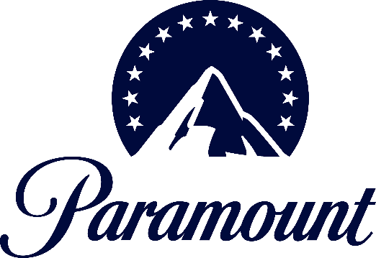

PARAMOUNT GLOBAL ANNOUNCES THE PARTICIPANTS FOR
THE 2024 “CBS SHOWCASE”

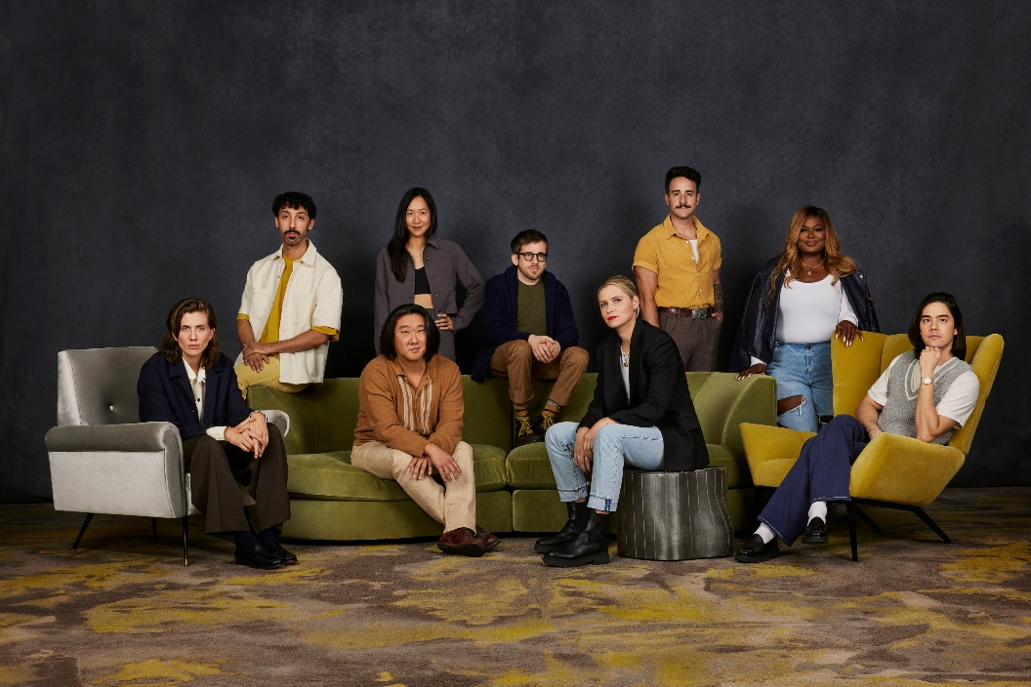
From L-R: E.R. Fightmaster, Morgan Jay, Peter S. Kim, Tien Tran, Brett Maline, Mo Welch, Gregory Santos, Rashida “Sheedz” Olayiwola, Jared Goldstein

Al Madrigal to Host the One-Night-Only Live Event

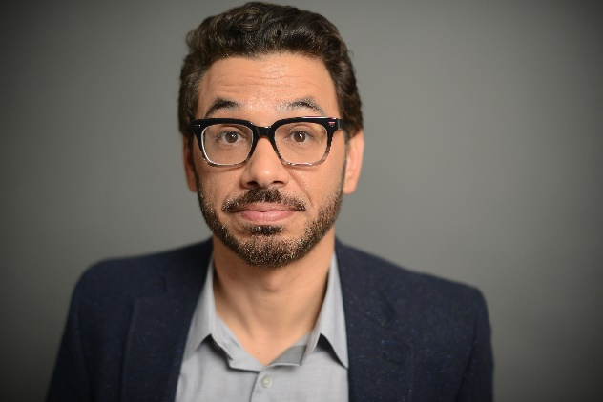

Click Here for Photos

LOS ANGELES – Jan. 24, 2024 – Paramount Global today announced the host and participants of Paramount’s 2024 CBS SHOWCASE, which will hold a one-night-only live event for an audience of industry professionals in Hollywood on Thursday, Feb. 1.

This year’s SHOWCASE will shift formats with a celebratory evening of live standup comedy benefitting charitable organizations chosen by the program’s participants, including The Trevor Project, Feeding America, Parkinson’s Foundation Inc., Poverty Alleviation Chicago: Letters to Santa, Shriners Hospital for Children, Planned Parenthood Federation of America, Downtown Women’s Center and GLSEN. All performers are alumni of SHOWCASE and gifted multi-hyphenates who have gone on to find success on screen, behind the scenes, and on stages across the nation and beyond.

SHOWCASE will be hosted by comedian, writer and producer Al Madrigal (“Lopez vs. Lopez”) and feature standup from comics Jared Goldstein (“Black Mirror,” 2020 SHOWCASE), Morgan Jay (“Wild’n’Out,” 2021 SHOWCASE), Peter S. Kim (“Fairfax,” 2018 SHOWCASE), Brett Maline (“Loki,” 2016 SHOWCASE), Rashida “Sheedz” Olayiwola (“Jury Duty,” 2017 SHOWCASE), Gregory Santos (COMEDY CENTRAL STAND-UP FEATURING, 2020 SHOWCASE), Tien Tran (“How I Met Your Father,” 2019 SHOWCASE), and Mo Welch (“Krapopolis,” 2014 SHOWCASE). The show will be followed by a performance from musical guest FIGHTMASTER, the solo project of nonbinary actor and writer E.R. Fightmaster (“Grey’s Anatomy,” 2019 SHOWCASE).

Recognized by many as the industry leader in actor showcases designed to spotlight up-and-coming talent, Paramount’s CBS SHOWCASE is an award-winning program that has been acknowledged by an impressive list of global film festivals including OUTFEST, the Academy Award-qualifying Indy Shorts International Film Festival, Dances with Films, Salute Your Shorts and the San Diego International Film Festival, to name a few. SHOWCASE has also been spotlighted in publications like Forbes and The Los Angeles Times for its positive impact on the entertainment industry, particularly for introducing and amplifying BIPOC, disabled, queer and oftentimes intersectional voices that go on to have meaningful careers both in front of and behind the camera. SHOWCASE is overseen by the CBS Talent and Casting group in partnership with Paramount’s Office of Global Inclusion.

“We are so excited to see the return of our esteemed alumni for this year’s live show. Each participant was a standout of SHOWCASE, whether they contributed as a writer, performer or both, and we are proud of what they have accomplished since” said Claudia Lyon, EVP of talent and casting, and Dorey Poder, VP of talent and casting, in a joint statement. “After these last few years of working from home and missing out on live entertainment, we are looking forward to bringing people together under one roof to laugh, celebrate and reacquaint themselves with these wonderful artists.”

AL MADRIGAL (Host): On television, Madrigal is best known as the senior Latino correspondent on THE DAILY SHOW WITH JON STEWART and is currently a series regular on NBC’s hit comedy “Lopez vs. Lopez.” Madrigal’s many film credits include “The Way Back” with Ben Affleck for Warner Bros and “Night School” alongside Kevin Hart and Tiffany Haddish. As a writer, Madrigal has written on multiple television shows, including “I’m Dying Up Here” and BROKE with Jaime Camil. Currently, he’s developing multiple projects for TV within his current deal at CBS Studios. In 2022, Al teamed up with AWA and former Marvel editor-in-chief Axel Alonso to release “Primos.” As an entrepreneur, Madrigal and fellow comedian Bill Burr founded All Things Comedy (ATC), which has become the #1 comedy podcast network in the world. He’s also produced several movies and television shows, including “Old Dads” for Netflix and “Drugstore June,” which will be released on Feb. 23, 2024. Madrigal is repped by Sam Bringardner and Brett Loncar at Creative Artists Agency.

JARED GOLDSTEIN (Comic): Jared Goldstein is an LA-based standup comedian. He was chosen as one of 2022’s Just for Laughs New Faces of Comedy as well as Vulture’s 2021 Comedians to Know. He can currently be seen starring opposite Annie Murphy in Netflix’s hit series “Black Mirror” and on the Roku series “Nikki Fre$h,” starring as Nicole Richie’s trusty right hand. His other credits include Hulu’s “Dollface” and CBS’ THE UNICORN. Additionally, Jared’s standup premiered on COMEDY CENTRAL STAND-UP FEATURING and in 2019 he was chosen as one of New York Comedy Festival Comics to Watch as well as Time Out’s Comedians to Watch. Jared also participated in the 2020 CBS SHOWCASE. Previously, he’s appeared on ABC’s “Modern Family,” “Counterpart” with JK Simmons for Starz, “Rizzoli & Isles” and the feature film “It’s Kind of a Funny Story” starring Zach Galifianakis. Goldstein is repped by United Talent Agency and Mosaic.

MORGAN JAY (Comic): A musician and comedian based in LA, Morgan has made appearances on MTV’s “Wild’n’Out,” Peacock’s “Girls5Eva,” NBC’s “Bring the Funny,” “Night Court” and more. He’s Brazilian and Italian which for some reason makes him the guy from “Ratatouille.” Low key, he’s a trained actor who graduated from the Tisch School of the Arts at NYU. He’s performed at numerous comedy festivals, won multiple awards, was a 2023 Just For Laughs New Face and has two comedy specials available on YouTube … But none of that stuff really matters anymore because he has a lot of followers on social media (2.6 million on TikTok!) and that is all that matters. He has a social media presence and a blue check mark. I’m just saying he’s a huge deal. That’s all I’m saying. Jay is repped by Brillstein Entertainment Partners.

PETER S. KIM (Comic): Peter S. Kim is a standup comedian, actor and writer. He recently staffed on the FOX animated series “Housebroken” and is currently developing a multi-cam at NBC. He recently shot the sketch comedy pilot presentation “Seoul Hunters” for WarnerMedia, and previously developed with FOX and ABC. As an actor, Peter can next be seen starring as Paul in the feature film “A Nice Indian Boy,” which will premiere at the 2024 SXSW Festival, and in the indie feature “Larry in the Sky with Diamonds.” Peter is a series regular on the Amazon animated series “Fairfax” and his other acting credits include HBO’s “Curb Your Enthusiasm,” CBS’ NCIS, SeeSo’s “Shrink” and NBC’s “Chicago Justice.” When not on screen or writing, he tours nationally performing standup and is currently on the road with Eunji Kim, the co-host of his podcast “2 Kims One Pod.” He was selected as a New Face at the 2021 Just for Laughs Comedy Festival, wrote for the 2020 CBS SHOWCASE and was a performer in the 2018 CBS SHOWCASE. His other stage credits include performing and writing for the Second City Chicago stage where he was nominated for a Jeff Award in the critically acclaimed “A Red Line Runs Through It.” Kim is repped by Artists First, Creative Artists Agency and attorney Adam Cooper at Jackoway Austen Tyerman Wertheimer Mandelbaum Morris Bernstein Trattner & Klein.

BRETT MALINE (Comic): Brett Maline is an LA-based multi-hyphenate, award-winning disabled actor/writer/director. From small town Nebraska, he’s niche because he lives with a rare type of scoliosis and drives a crappy PT Cruiser. Named to the 2023 Inevitable Foundation Elevate Collective Cohort, Brett received a grant and executive mentorship to develop his original TV and film scripts. He also wrote on the second season of Marvel’s “Loki” while developing his half-hour comedy with Sony Pictures Television, supervised by Dayna Lynne North. With appearances on CBS, NBC, FOX, Amazon Prime and Disney, Brett is a former cast member of the 2016 CBS SHOWCASE, Groundlings Sunday Company alum and a UCB house sketch team veteran. He continues to write, direct and produce videos for his YouTube channel “Genuine Jerks,” which has been featured on the “Today Show,” “Good Morning America” and Vulture. Maline is repped by Omnipop Talent Group.

RASHIDA “SHEEDZ” OLAYIWOLA (Comic): Rashida “Sheedz” Olayiwola is a writer, actor and comedian from Chicago, Ill., who currently resides in Los Angeles. Olayiwola was most recently seen starring in Amazon Freevee’s award-winning, docu-style comedy television series “Jury Duty” opposite James Marsden. Next up, Olayiwola will be seen starring in Disney+/Marvel Studios’ highly anticipated series “Ironheart.” On the animation front, Olayiwola wrote and will star in Netflix/Sony Pictures Television animated series “Good Times,” a reboot of the original live-action television series that aired on CBS. Previously, Olayiwola worked as a writer and actor on the critically acclaimed MAX series “South Side,” as well as IFC/AMC’s “Sherman’s Showcase.” Olayiwola has written for a handful of awards shows including the BET Awards, BET Hip Hop Awards and the Soul Train Awards. In the world of standup, Olayiwola has opened for Arsenio Hall, Hannibal Burress, Aida Rodriguez and Michael Che, among others. Additional credits include: “Insecure,” “A Black Lady Sketch Show,” “Empire,” “Chicago P.D.” and THE LATE SHOW. Olayiwola is repped by Independent Artist Group (IAG), Zero Gravity Management and Persona PR.

GREGORY SANTOS (Comic): Gregory Santos is a Cuban-American comedian, actor and writer originally from Las Vegas, Nev. He was featured in the 2020 CBS SHOWCASE and was given a talent holding deal by the Network (then the pandemic happened, awesome!). Gregory has been featured on Comedy Central for his standup, guest starred on multiple television shows including CBS’ THE NEIGHBORHOOD, ABC’s “American Housewife” and NBC’s “Great News,” supported in short films and is regularly seen in national commercials. He has also created digital shorts that have garnered millions of views across multiple platforms. He is 5’8” and willing to shave. Santos is repped by Haven.

TIEN TRAN (Comic): Tien Tran is a comedian, actress and writer from Chicago. She can most recently be seen in the HOW I MET YOUR MOTHER reboot “How I Met Your Father” for Hulu from “This Is Us’s” Isaac Aptaker and Elizabeth Berger. Tien was a writer on both seasons of Showtime’s WORK IN PROGRESS produced by Jax Media. She can be seen in Netflix’s “Space Force” and “Easy,” IFC’s “Sherman’s Showcase,” Pop TV’s “Hot Date” and she’s been featured as part of Comedy Central and Refinery29’s standup series “Taking the Stage.” Tien was named one of the 2019 Just For Laughs New Faces of Comedy. In 2018, she participated in CBS’ SHOWCASE and became head writer for the SHOWCASE the following year. She is a veteran member of the prestigious Second City Mainstage in Chicago. Tran is repped by Creative Artists Agency and Mosaic.

MO WELCH (Comic): Mo Welch is an LA-based comedian, actress, writer and cartoonist. Mo wrote on staff for Dan Harmon’s FOX animated series “Krapopolis,” which premiered last fall. Her book, How to Die Alone: The Foolproof Guide to Not Helping Yourself (Featuring Blair), was released in 2019 by Workman Publishing and is based on her Instagram comic strip Blair, which has over 120K followers. She sold and developed an animated series based on the comic strip with Chelsea Handler producing. As a performer, Mo has opened for Chelsea Handler, Anthony Jeselnik and Brett Goldstein. She has performed on Conan (twice), and she wrote on staff for GOOD TALK WITH ANTHONY JESELNIK (Comedy Central). Mo’s podcast “Come Out, Come Out” was released through Audible in December 2020. Her comics have been published in The New Yorker, Cosmopolitan Magazine, Vice and elsewhere. Her other on-screen credits include CORPORATE (Comedy Central), LIFE IN PIECES (CBS) and “Gortimer Gibbon’s Life on Normal Street” (Amazon). Welch is repped by United Talent Agency and attorney Grace Kallis at Ginsburg Daniels Kallis.

E.R. FIGHTMASTER (Musical Guest): E.R. Fightmaster is a nonbinary actor, writer, director and musician living in Los Angeles. They got their start on stage improvising at The Second City comedy theater in Chicago. Now you can watch them onscreen in series like Hulu’s “Shrill,” Showtime’s WORK IN PROGRESS or ABC’s “Grey’s Anatomy” playing network television’s first nonbinary doctor. They are a writer for the hit A24/Netflix comedy series “Survival of the Thickest” and the director of the stage show “Quit While I’m Behind,” starring comedian Lily Sullivan. In October of 2023, E.R. released their first solo music EP, Violence, under the moniker FIGHTMASTER and are set to release a follow-up EP in 2024. A proud advocate for the Queer community, they are the 2023 recipient of the Human Rights Campaign Visibility Award. Fightmaster is repped by United Talent Agency, Entertainment 360; FIGHTMASTER (band) is repped by Range Media Partners.

Alumni of SHOWCASE include Emmy Award winner Kate McKinnon (“Saturday Night Live”), Academy Award and Golden Globe nominee Hong Chau (“The Whale”), Emmy Award nominees Nicole Byer (“Nailed It!”) and Punam Patel (“Special”), Critics Choice Award nominee Drew Tarver (“The Other Two”), Hollywood Critics Association Award winners Nico Santos (“Superstore”) and Rosa Salazar (“Alita: Battle Angel”), Imagen Foundation Award winner Jesse Garcia (“Flamin’ Hot”) and nominee Sheila Carrasco (GHOSTS), Diona Reasonover (NCIS), Jay Lee (CSI: VEGAS), Gina Yashere (BOB HEARTS ABISHOLA), Leah Lewis (MATLOCK), Geoffrey Arend (MADAME SECRETARY), Justin Hires (MACGYVER), Ego Nwodim (“Saturday Night Live”), Hasan Minhaj (THE DAILY SHOW), Melissa Villaseñor (“Saturday Night Live”), Karan Soni (“Deadpool”), Aida Osman (“Rap Sh!t”), Fortune Feimster (“Fubar”), Haneefah Wood (“Truth Be Told”), Colton Dunn (“Superstore”), Eugene Cordero (STAR TREK: LOWER DECKS), Carmela Zumbado (“Power Book IV: Force”), Brianna Baker (“9-1-1: Lone Star”) and Wyatt Cenac (THE DAILY SHOW), among numerous others.

Click here for more information on Paramount’s CBS SHOWCASE: https://www.paramount.com/showcase.

Additional details regarding Paramount’s diversity and inclusion efforts can be found here: https://www.paramount.com/inclusion-2021/introduction.

***

Press Contact:
Noelle Llewellyn | noelle.llewellyn@viacomcbs.com

Photo Contacts:
Jess Sokolowski | jess.sokolowski@viacomcbs.com
Heidi Rubin | heidi.rubin@viacomcbs.com

