BET DIGITAL RELEASES SHORT-FORM DOCUMENTARY “FLIPPED” – AVAILABLE NOW ON BET.COM AND THE OFFICIAL BET YOUTUBE CHANNEL
Directed by award-winning filmmaker Deborah Riley Draper, “Flipped” is a powerful film that chronicles Fisk University’s groundbreaking launch of the first HBCU women’s collegiate gymnastics team in 2023.
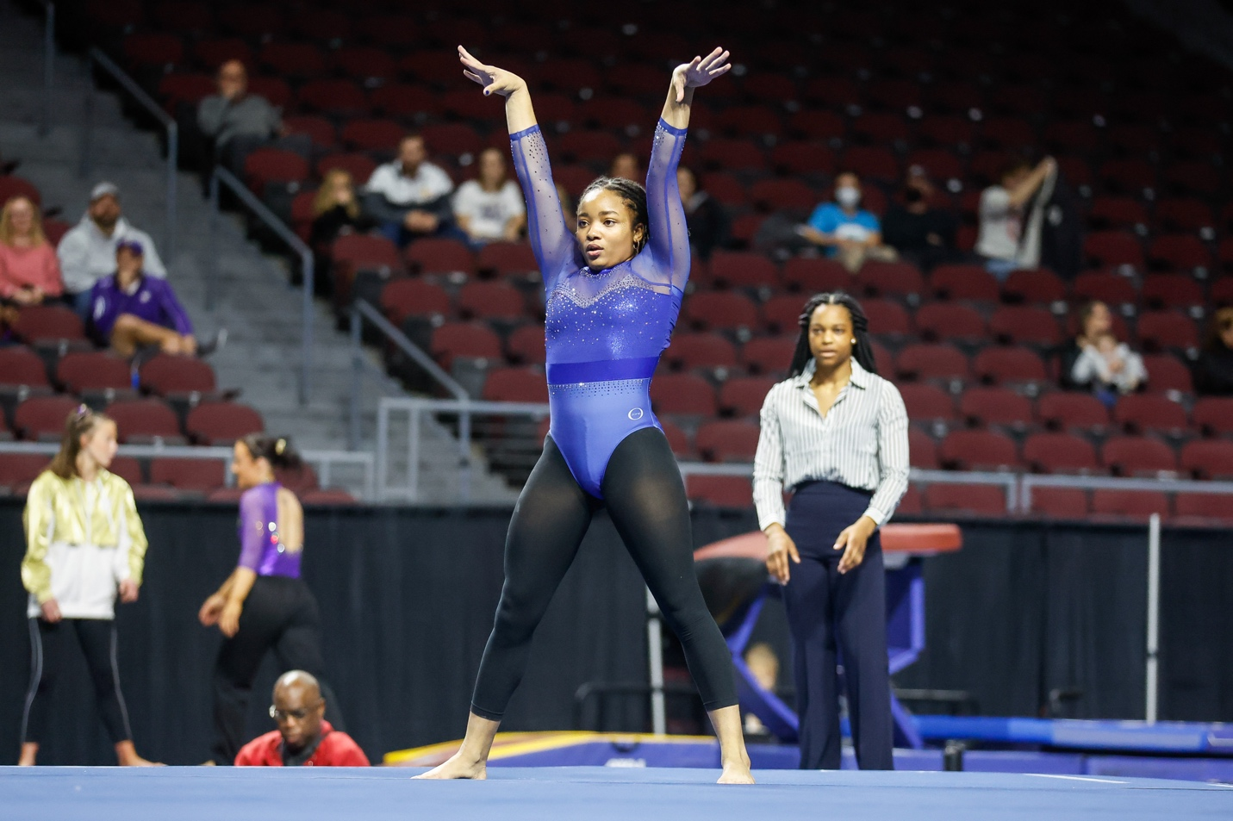
WHAT: BET Digital has released the short-form documentary “Flipped,” which follows the groundbreaking journey of Fisk University’s historic launch of the first-ever HBCU women’s collegiate gymnastics team. The film traces the program from its inaugural 2023 season to a surprising and heartbreaking end just three years later, revealing how a group of determined young Black women built a team from virtually nothing—with no dedicated gym, no trainer, and limited funding—into a powerful symbol of triumph and perseverance. Competing fifty years after the passage of Title IX, the women-of-color student-athletes of Fisk University’s gymnastics team break records and upend the status quo in a gripping David vs. Goliath story, making “Flipped” a must-watch sports documentary that captures the triumphs, sacrifices, and unbreakable spirit of young trailblazers who dared to create something that had never existed before.
WHO: Directed by award-winning filmmaker and writer Deborah Riley Draper and produced by Robin Lyon. Starring Fisk University athletes Naimah Muhammed, Ziya Coleman, Jordan Cromartie, Morgan Price, and Kiara Richmond. Produced by Coffee Bluff Pictures and Baller Alert Films and distributed by BET Digital.
WHEN: Tuesday, April 7, 2026
WHERE: “Flipped” is available now to stream on BET.com and the official BET YouTube channel.
QUOTES
“Directing Flipped is a celebration of brilliance, resilience, and the power of possibility. Fisk University’s historic gymnastics team is another chapter in Black excellence—grace meeting grit, discipline meeting destiny. Bringing their story to the screen expands the lens of the American narrative and reminds us that when we share our stories fully and fearlessly, we elevate the spirit of us all.”
— Deborah Riley Draper, Director
“Flipped comes at a time when these stories are not only relevant, they are necessary. My goal was to spotlight a powerful moment in history and give it the platform it deserves. As the first project under Baller Alert Films, this is about legacy, visibility, and making sure these women are recognized for what they’ve accomplished, both on and off the mat. BET is the right partner to help bring this story to the audience it was made for.”
— Robin Lyon, Producer
SERIES KEY ART & STILLS – HERE
ABOUT BET MEDIA GROUP
The BET Media Group, a unit of Paramount, a Skydance Corporation (Nasdaq: PSKY), is the world’s largest media company rooted in community, culture, and connection for the Black community. For over four decades, BET has served as a trusted home for Black audiences, amplifying authentic stories, elevating Black voices, and creating spaces where culture thrives and community comes together.

Through a powerful portfolio of brands—including BET, BET Her, BET Studios, and VH1—along with FAST channels such as BET Tyler Perry Comedy, BET Tyler Perry Drama, BET Comedy Movies, BET Cinema, BET Classics, BET Visionaries, BET Throwbacks, and BET Pluto, BET connects audiences across cable, digital, live events, studios, and global platforms. Together, these platforms deliver culturally resonant content that reflects the depth, creativity, and impact of the Black experience.

For more information, visit www.bet.com and follow @BET on social platforms. For additional announcements, visit paramountpressexpress.com/bet/.

ABOUT COFFEE BLUFF PICTURES
Coffee Bluff Pictures is an award-winning production company founded by filmmaker and former advertising executive Deborah Riley Draper. The company develops and produces films, television, and commercial campaigns, centering seminal yet often untold, mistold, misrepresented, and overlooked voices and characters that shape American history. Its work includes Ratified (PBS/Independent Lens), The Legacy of Black Wall Street (OWN/discovery+), and the fashion classic Versailles ’73: American Runway Revolution, named one of Harper’s Bazaar’s best documentaries of all time.
For more information, visit www.coffeebluffpictures.com.

ABOUT BALLER ALERT FILMS
Baller Alert Films is the film and television division of Baller Alert, founded in 2020 to expand the brand’s storytelling into premium visual content. The company develops and produces culturally driven films and series that spotlight underrepresented voices and real stories shaping contemporary culture. With a focus on impactful documentary and original programming, Baller Alert Films is committed to bringing authentic narratives to audiences across major platforms.

